Running Title: Metabolites of marine antagonistic bacteria
LC-MS based identification of secondary metabolites from marine antagonistic endophytic bacteria

Fehmida Bibi¹*, Muhammad Imran Naseer², Muhammad Yasir¹, Ahmed Abdullah Khalaf Al-Ghamdi³, Esam Ibrahim Azhar^{1,3}

¹Special Infectious Agents Unit, King Fahd Medical Research Center, King Abdulaziz University, Jeddah, Saudi Arabia
²Center of Excellence in Genomic Medicine Research (CEGMR), King Abdulaziz University, Jeddah, 21589, Saudi Arabia
³Department of Medical Laboratory Technology, Faculty of Applied Medical Sciences, King Abdulaziz University, Jeddah, Saudi Arabia

*Correspondence to:
Dr. Fehmida Bibi, Ph.D
Special Infectious Agents Unit, King Fahd Medical Research Centre, King Abdulaziz University, Jeddah, Saudi Arabia
Tel: +966-2-64010000 Ext. 73529 Fax: +966-2-6952076
E-mail: fehmeedaimran@yahoo.com

Abstract
Halophytes occupy coastal and sub-coastal area of marine environment. They potential candidates for search of novel and new bacterial flora that have immense potential to yield novel therapeutic agents. Six different endophytic bacteria have been isolated from pneumatophores and roots of three halophytes (Salsola imbricata, Avicennia marina and Haplopeplis perfoliata) collected from western coastal area of Jeddah, Saudi Arabia. After testing against five fungal pathogens all were active against oomycetes fungal pathogens, Phytophthora capsici and Pythium ultimum. Molecular identification of the bacteria was done on the basis of 16S rRNA gene sequences which revealed 95.9–99.4% sequence identity to related type strains and were placed in four major genera and two major classes: Actinobacteria (Streptomyces and Nocardioides) and α-Proteobacteria (Inquilinus and Labrezia). Active metabolites of these six bacterial endophytes including EA61, EA83, EA85, EA87, EA97 and EA220 were identified by subjecting to chemical analyses using liquid chromatography-mass spectrometry (LC-MS). LC-MS analyses showed presence of different active compounds in the culture extracts of these isolates. Some of these metabolites are already reported as synthetic molecules and has diverse biological functions as antimicrobial, anti-inflammatory and anthelmintic compounds such as such as Sulfamethoxypyridazine, Sulfamonomethoxine, Sulfamerazine and Dimetridazole, Sulfadiazin. Nalidixic acid and Oxibendazole. This study provides an insight into potential bacterial flora of halophytes producing bioactive metabolites of medical significance.

Keywords: Halophytes, antagonistic bacteria, 16S rRNA gene sequence, LC-MS analyses, metabolites identification

INTRODUCTION
The rise in resistant microorganisms to antibiotics is one of the risk in health sector and rate of death is high worldwide due to infectious diseases (Nascimento et al., 2000). Therefore, there is need for discovery of new drugs from different sources to combat against these infectious diseases. Halophytes are salt tolerant plants that inhabit in saline environment such as sand dunes and rocky coastal area. Under these unfavorable conditions of salinity, anaerobic conditions, tides, winds, and high temperatures favor different types of physiological traits to develop and help to withstand in harsh conditions. This habitat enables halophytes under these stressful conditions to include unique and novel microflora with diverse secondary metabolites and biological functions. This microflora of marine plants may be useful in finding the effective and useful biomolecules and drugs for the treatment of human diseases (Haefner, 2003).
Marine flora especially bacteria yielded secondary metabolites that have anti- inflammatory, anticancer, and antimicrobial properties. Halophytes contain different types of active metabolites in their culture extract with antimicrobial activities (Bandaranayake, 2002). Extracts from halophytes have been reported to show biological activities such as antibacterial, antifungal, cytotoxic, neurotoxic and antiviral (Chandrasekaran et al., 2009; Premanathan et al., 2009). As a potential source for such active secondary metabolites halophytes are an ideal source for investigation of associated microorganisms and their bioactive compounds. Microflora of halophytes comprises both rhizospheric and endophytic bacteria which play important role for the host survival and well being. Halophyte associated microflora produce secondary metabolites and provides several beneficial effects including resistance against plant pathogens (Chung et al., 2003). Halophytes associated bacterial communities are beneficial for the host and perform different functions inside and outside of host by yielding useful enzymes and antibiotics (Roy et al., 2002; Thatoi et al., 2013). Endophytic marine bacteria from halophytes always possess a broad spectrum of antimicrobial activities and help in survival of host against different b bacterial and fungal pathogens (Hu et al., 2010; Jose et al., 2013). Despite of their importance endophytes from halophytes are least studied. There are also few studies from coastal areas of the Red sea and for halophytes associated endophtic bacterial flora.
Recently, for identification of secondary metabolites metabolomics approach has been used to identify metabolites (Rochfort, 2005). For identification of complex metabolites liquid chromatography-mass spectrometry (LC-MS) is used to identify unknown compounds from complex samples. This technique is high-throughput and highly sensitive to for detection and identification of unknown compounds present in biological samples (Villas-Bôase et al., 2005; Lee et al., 2011).
Therefore, we designed a study for identification of the selected six endophytic bacteria isolated from three different halophytes (Salsola imbricata, Avicennia marina, Haplopeplis perfoliata) using 16S rDNA sequencing and further identification of metabolites using LC-MS technique. Different bioactive compounds have been identified from culture extract of these bacteria such as Sulfamonomethoxine, Metronidazole-oh, Ibuprofen, Sulfadiazin, Sulfacetamide, Diazepam and Oxibendazole.

MATERIALS AND METHODS
Sample collection and isolation of endophytic bacteria from halophytes
Six different bacterial strains have been isolated in a study (unpublisehd) from three different halophytes specimens (Salsola imbricata, Avicennia marina and Haplopeplis perfoliata) were collected from coast of Thuwal region in Jeddah, Saudi Arabia. These six bacterial strains were isolated from sterilized roots and pneumatophores after washing with disinfectants as described previously (Bibi et al., 2017). After sterilization of roots leaves and pneumatophores segments, small pieces of sterilized roots, leaves and pneumatophores segments were ground in FAS using sterile mortar and pestle. Aliquots were further serially diluted (10⁻³, 10⁻⁴ and 10⁻⁵) and plated in triplicate on half strength R2A (½ R2A) and starch-casein agar (Himedia) in sea water supplemented with cycloheximide and nystatin 50μg/ml) and plates were incubated at 25°C for 2 weeks for bacterial growth. Pure bacterial strains were further stabbed and stored in 15% (v/v) glycerol stock of strains at -70°C in King Fahd Medical Research Centre and given lab number (Table. 1).

Screening for antifungal activity and identification16S rRNA gene sequencing
These six bacterial strain were tested against five different fungal pathogens; Phytophthora capsici (P. capsici), Pythium ultimum (Py. ultimum), Magnaporthe grisea (obtained in this laboratory) Altenaria malli (KCTC 6972) and Fusarium moniliforme (KCTC 6149) obtained from Korean type culture collection centre (KCTC). Antagonistic activity against fungal pathogens was determined by using cross streak method and identified using 16S rRNA gene sequencing as described previously (Bibi et al., 2017).

Bacterial DNA extraction of and 16S rRNA gene sequencing
Genomic DNA was extracted from the selected antagonistic bacterial isolates using a DNA extraction kit (Thermo Scientific, Waltham, USA). To identify antagonistic bacteria, 16S rRNA gene sequencing was performed. Using bacterial universal primers 27F (5'-AGAGTTTGATCCTGGCTCAG-3') and 1492R (5'- GGTTACCTTGTTACGACTT -3'), the 16S rRNA gene fragment was amplified under following PCR conditions: one cycle of 95°C for 5 min followed by 28 cycles of 95°C for 1 min, and annealing at 58°C for 50s with extension at 72°C for 50s, and a final extension step at 72°C for 10 min. PCR products were purified using PCR purification kit (Thermo Scientific, Waltham, USA), and sequenced commercially (Macrogen, South Korea). 16S rRNA gene sequences obtained were blast using the EzTaxon server (http://eztaxon-e.ezbiocloud.net) to identify antagonistic bacteria. Phylogenetic positions of the antagonistic bacteria were confirmed using CLUSTALX multiple alignments of the bacterial sequences were performed and BioEdit software was used to edit the gaps. The neighbour-joining method in the MEGA6 Programme was used for construction of the phylogenetic tree based on the 16S rRNA gene sequences .

Optimization of bacterial culture condition for production of antifungal activity
To optimize culture conditions of selected bacterial strains for the production of antifungal activities, an appropriate medium for culturing was selected. Four different media i.e ½ R2A broth, ½ TSB, ½NB in sea water and Marine broth in distilled were used for culturing. After every 24hrs optical density (OD) was checked and antifungal activity was assessed against P. capsici, Py. ultimum using disc diffusion method. The effect of temperature was checked at different ranges of temperatures (20 to 40°C) in ½ R2A broth. For pH optimization, different ranges of pH values (5–12) were used for the growth and antifungal compound production in ½ R2A broth.

LC-MS analysis of bacterial culture
5ml bacterial culture was placed on -80°C for 5mins, and then transfer to 37°C water bath for 5mins and repeats this procedure 5 times. Centrifuge at 15000g for 10 minutes and transfer 3ml supernatant to tube and add 12ml acetonitrile and vortex for 30sec. Centrifuge again at 15000g for 10 minutes and 300µl supernatant was taken for LC-MS metabolomics analysis. Injection volume was 3µl and samples are analyzed on Agilent 6540B TOF/Q-TOF Mass Spectrometer coupled with Agilent 1290 UPLC and Dual AJS ESI ion source. An ACQUITY UPLC HSS T3 (100×2.1mm, 1.8 um) column and pre-column (Phenomenex Security Guard™) is used to separate sample. Column temperature was set to 45°C and flow rate was 0.5ml/min. Acquisition range was from 50m/z to 1500m/z and scan rate was 1.00 spec/sec. MS parameters was set as follow: capillary voltage 3500 V, nebulizer pressure 35 psi, drying gas 10L/min, gas temperature 325°C, vaporizer 200V, voltage charge 1000V; negative-ion mode capillary voltage 3500V, corona negative 15.0V, fragmentor 175V, skimmer1 65.0V, octopole RF Peak 750V; positive ion mode capillary voltage 3500V, corona positive 4.0V, fragmentor 175V, skimmer1 65.0V and octopole RF Peak 750V. Raw data was imported to Agilent MassHunter Qualitative Analysis B.06.00 software. Metabolites were identified by in-house database.

RESULTS
Isolation and screening of endophytic bacteria from halophytes
In this study, three halophytes samples were collected from western coastal area of Jeddah and endophytic bacteria were isolated from roots and pneumatophores of halophytes. These six bacterial endophytes were further screened for their antagonistic activity against five pathogenic fungi i.e Pythium ultimum, Phytophthora capsici, Magnaporthe grisea, Altenaria mali and Fusarium oxysporum. Six endophytes showed activity against both Py. ultimum and P. capsici and some were not active against other fungal pathogens tested. Strain EA61 showed activity against four fungal pathogens and were negative against F. oxysporum. Similarly strain EA97 and EA220 were positive against Py. ultimum, P. capsici and M. grisea while negative for other two. While strain EA83, EA85 and EA87 were only active against Py. ultimum and P. capsici oomycetes fungi (Table 1).

Identification of antagonistic bacteria based on 16S rRNA gene sequence
Six antagonistic bacteria were identified by using 16S rRNA gene sequence analysis. Four of them, EA61, EA83, EA85 and EA87 belong to Actinobacteria. While strain EA97 and strain EA220 belong to α-Proteobacteria (Table 1). Sequence identity of antagonistic bacteria were from 95.9%–99.4% (Table 1). The phylogenetic tree inferred using 16S rRNA gene data showed that branching patterns remained constant. High bootstrap values were recorded in the phylogenetic tree using 16S rRNA gene sequences data (Figure 1a). Two different clusters has been generated for isolates of class Actinobacteria. Antagonistic strains of class Actinobacteria were placed in a separate cluster recovered with higher bootstrap values of 99-100%. Antagonistic bacteria in Actinobacteria mainly belonged to the genera Nocardioides and Streptomyces. Representative isolates in this class belong to four different genera i.e Nocardioides, Arthrobacter, Streptomyces, and Mycobacterium. Two strains of α-Proteobacteria were palced in two separate clusters also showing high bootstrap values (91%–100%). The representative strains of α-Proteobacteria belong to two different genera i.e Labrenzia and Inquilinus. Two strains EA85 and EA97 were novel and new antagonistic endophytic bacterial strains showing low 16S rRNA gene sequence similarity (<97%) (Table 1). In phylogeentic analysis Bacillus subtiils was used as an outgroup.

Culture condition optimization and identification of metabolites by LC-MS
Culture media tested for optimization of bacterial growth ½ R2A broth was found to be the best culturing media. Selected strains showed best growth at pH 7.5 and 28°C in the shaking incubator (140rpm). After optimization of conditions, selected bacterial strains were grown in 5ml ½ R2A broth in sea water for 36-48 hours until OD₆₀₀ reached 0.9. LC-MS analyses of culture of these six strains identified different chemical constituents (Figure 2a-7b and Table 2). LC-MS analysis was performed to identify known and unknown metabolites from culture extract. LC-MS analysis showed presence of various active metabolites in culture extract of all six bacteria strains. All of these compounds although are not new but are known as synthetic molecule and not have their origin from bacteria. Identification of metabolites was determined by LC-MS analysis and comparing results from NIST database. Strain of Streptomyces sp. (EA61) showed peaks for only four secondary metabolites in both the positive- and negative-ion mode (Figure 2a and b). These compopunds include Sulfamonomethoxine, Metronidazole-oh, Ibuprofen and Dimetridazole. For non-streptomyces, Nocardioides sp. (EA83), eight different peaks were identified for active compounds including Sulfamonomethoxine, Metronidazole-oh, Sulfadiazin, Sulfaethoxypyridazine, Ibuprofen, Gemfibrozil, Dimetridazole and Nalidixic acid were detected in the both positive and negative-ion mode (Figure 3a and b). Strain of Streptomyces (EA85) showed the presence of 4 bioactive compounds in their culture extract i.e Sulfamonomethoxine, Sulfadiazin, Ibuprofen, and Metronidazole-oh (Figure 4a and b). Another non-streptomyces, Nocardioides sp. (EA87) showed peaks of only five active metabolites in both positive- and negative-ion mode have been detected among hundred others. These bioactive metabolites include Allopurinol, Nalidixic acid, Ibuprofen, Sulfacetamide and Metronidazole-oh (Figure 5a and 5b). For Strain EA97 closely related to Inquilinus limosus, four active compounds have been detected among hundreds of peaks for different metabolites. These four compounds include Nalidixic acid, Diazepam, Ibuprofen, Sulfacetamide and Metronidazole-oh (Figure 6a and 6b). LC-MS analysis of strain EA220, Labrenzia alexandrii showed the presence of three bioactive compounds among several compounds detected. These bioactive compounds include, Allopurinol, Diazepam and Oxibendazole (Figure 7a and 7b). These bioactive secondary metabolites are already known for their activities.

DISCUSSION
Due to emergence of resistant bacteria to different antibiotics there is need of discovering new drugs to combat different infectious diseases. Currently, marine environment especially halophytes under extreme environmental conditions become a source for discovery of new therapeutic agents (Malve, 2016). These harsh conditions lead them to produce certain metabolites enabling them to survive under these harsh conditions (De Carvalho & Fernandes, 2010). In this study, we have selected six different antagonistic bacteria active against fungal pathogens. These endophytic bacteria were isolated from roots and Pneumatophores of different halophytes mentioned in Table 1. Secondary metabolite production by endophytic bacteria is one of the phennomenon used by bacteria to defend host against different pathogens and predators (Coombs et al., 2004). Halophytes associated bacterial flora has potential to produce different bioactive metabolites (Hu et al., 2010). These bacterial endophytes belong to two different classes of Actinobacteria and α-Proteobacteria. Four strains, EA61, EA83, EA85 and EA87 belong to two different genera Streptomyces and Nocardioides placed in Actinobacteria i.e. Class α-Proteobacteria also comprises of two different strains EA97 and EA225 belong to genera Inquilinus and Labrenzia.
Marine actinomycetes are major source for discovery of new and novel natural products. Marine Actinobacteria prodcue novel antimicrobial and anticancer compounds such as salinosporamides, potential anticancer agent isolated from species of Salinispora and is in clinical trials for use as anticancer agents (Fenical et al., 2006). Previously, different strains of Actinobacteria isolated from halophytes showed antimicrobial activity against different human pathogenic bacteria (Lee et al., 2014). Halophytes growing near coastal areas are potential source for isolation of microbial flora especially Actinobacteria because of chemodiversity in environmental factors of that habitat. Presence of major numbers of Streptomyces strains amongst antagonists from halophyte are in accordance previous studies (Eccleston et al., 2008; Ravikumar et al., 2012).
From marine sources different strains of α-Proteobacteria were reported to be in symbiosis, nitrogen fixers and capable of producing antibiotics (Wagner-Döbler et al., 2002; Castro et al., 2014). Antibiotic production by streptomycetes is significant feature and new bioactive compounds have been isolated from different environment (Fiedler et al., 2005). Most of the endophytic bacteria in our study belong to Actinobacteria and were recovered from roots and pneumatophores. Several studies reported diverse bioactive compounds including steroids, peptides, alkaloids, terpenoids, quinines, flavonoids and phenols from halophytes associated endophytic bacteria (Newman and Cragg, 2007). Inside halophyte, endophytic streptomycetes are important niche, taking nutrients from host and in turn provide protection against different pathogens. These endophytic bacteria produce metabolites that are not toxic to host plant and are important bioactive metabolites in drug discovery (Castillo et al., 2007; Moyer, 2009).
Production of antifungal metabolite was enhanced by culturing in R2A as culture media using optimum culture conditions. The maximum antifungal activity was observed after 48hrs of growth at 28°C with pH 7.5. We used LC-MS technique mainly focus on polar metabolites (especially phosphate-containing compounds), most of which cannot be analyzed using GC-MS. LC-MS confirms presence of various active compounds although not novel but already known for their bioactivity. Two strains of endophytic Streptomyces (EA61 and EA83) produce Sulfamonomethoxine, Sulfadiazin, Metronidazole-oh, Ibuprofen and Dimetridazole. These compounds are known for antimicrobial, antiphytopathogenic and as biocontrol agents. These antibacterial sulfonamides are synthetic antimicrobial agents and also used as antibiotic in different inflammatory diseases (Vicente and Pérez-Trallero, 2010). Two endophytic bacteria belong to genus Nocardioides showed spectra of ten different active compounds including antibacterial, antifungal and antiprotozoal compounds (Fig. 3a, b and 5a,b). Both these strains EA83 and EA87 showed presence of Sulfamonomethoxine, Metronidazole-oh, Sulfadiazin, Sulfaethoxypyridazine, Ibuprofen, Gemfibrozil, Dimetridazole and Nalidixic acid. While in strain EA87 Allopurinol and Sulfacetamide also detected (Table 2). These antagonistic marine Actinobacteria contain variety of bioactive compounds and showed wide range of activities including cytotoxicity, antibacterial, antifungal and anti-angiogenesis. As Gesheva and Vasileva-Tonkova (2012) reported production of different antimicrobial compounds by marine species of Nocardioides. Strain EA83 showed close similarity of 99.4% on the basis of 16S rDNA to type strain of Nocardioides aromaticivorans H-1^{T} that was previously isolated from contaminated river in Japan and ability to degrade both dibenzofuran and carbazole (Kubota et al., 2005). No antimicrobial compound yet reported from this strain as detected in our strain EA85. Similarly other strain EA87 has close relatedness to Nocardioides albus KCTC 9186 ^{T}. This strain of Nocardioides is already known for production of antimicrobial compounds such as rodaplutin (Dellweg et al., 1988). Bioactive compounds detected in strain EA87 are different and not reported before. Such as sulfacetamide is synthetic antibiotic effective against both gram-positive and gram-negative bacteria no reported before from any natural source. Two endophytic strains of α-Proteobacteria, EA97 and EA220 were effective against oomycetes fungi as well as against M. grisea. These both endophytic bacteria related to type strains of Inquilinus limosus DSM 16000 ^{T} and Labrezia alexandrii DFL-11^{T} respectively. These strain showed spectra for seven different bioactive compounds among hundred others present in their culture extract. These compounds are mainly Nalidixic acid, Diazepam, Ibuprofen, Sulfacetamide, Metronidazole-oh, Allopurinol and Oxibendazole. These bioactive metabolites from our study have medicinal uses due to antimicrobial, anti-inflammatory and anthelmintic activities. No such compound has been reported before in strains of Inquilinus and Labrezia. According to LC-MS analyses, all compounds detected in these six selected endophytic bacteria have their pharmaceutical and medicinal use and reported as anti-inflammatory, anthelmintic, antibacterial and antifungal compounds. Antifungal activities detected in these six strains are due to production of these bioactive metabolites secreted by antagonistic endophytic bacterial strains.

CONCLUSION
In this study, six antagonistic endophytic bacteria inhabiting pneumatophores and roots of halophytes from coastal area of Saudi Arabia, have been screened against pathogenic fungi and their potential active metabolites have been identified. Strains exhibited spectra of different bioactive compounds including known antibiotics and pharmaceutical compounds of synthetic nature not reported from natural source such as bacteria. These results suggest that marine coastal plants are reservoir of antagonistic bacterial flora which are potential source of bioactive metabolites and can be used in medicine and as biocontrol agent as well.

ACKNOWLEDGMENTS
This work was funded by the Deanship of Scientific Research (DSR), King Abdulaziz University, Jeddah, under grant No. (1433/141/430). The author, therefore, acknowledge with thanks DSR technical and financial support.

References
- Bandaranayake WM (2002). Bioactivities, bioactive compounds and chemical constituents of mangrove plants. Wetlands Ecology and Management 10: 421-52. https://doi.org/10.1023/A:1021397624349
- Bibi F, Ullah I, Alvi SA, Bakhsh SA, Yasir M, Al-Ghamdi AA, Azhar EI (2017). Isolation, diversity, and biotechnological potential of rhizo and endophytic bacteria associated with mangrove plants from Saudi Arabia. Genet. Mol. Res 16: gmr16029657. http://dx.doi.org/10.4238/gmr16029657
- Castillo UF, Browne L, Strobel G, Hess WM, Ezra S, Pacheco G, Ezra D (2007). Biologically active endophytic streptomycetes from Nothofagus spp. and other plants in Patagonia. Microb Ecol 53: 12-19. https://doi.org/10.1007/s00248-006-9129-6
- Castro RA, Quecine MC, Lacava PT, Batista BD, Luvizotto DM, Marcon J, Ferreira A, Melo IS, Azevedo JL. (2014). Isolation and enzyme bioprospection of endophytic bacteria associated with plants of Brazilian mangrove ecosystem. SpringerPlus 23: 382. https://doi.org/10.1186/2193-1801-3-382
- Chandrasekaran M, Kannathasan K, Venkatesalu V, Prabhakar K (2009). Antibacterial activity of some salt marsh halophytes and mangrove plants against methicillin resistant Staphylococcus aureus. World J Microbiol Biotechnol 2: 155-60. https://doi.org/10.1007/s11274-008-9869-1
- Chung BS, Aslam Z, Kim SW, Kim GG, Kang HS, et al. (2008). A bacterial endophyte, Pseudomonas brassicacearum YC5480, isolated from the root of Artemisia sp. producing antifungal and phytotoxic compounds. Plant Pathol J 24: 461-468. https://doi.org/10.5423/PPJ.2008.24.4.461
- Coombs JT, Michelsen PP, Franco CM (2004). Evaluation of endophytic actinobacteria as antagonists of Gaeumannomyces graminis var. tritici in wheat. Biol Control 29:359-366. https://doi.org/10.1016/j.biocontrol.2003.08.001
- De Carvalho CC and Fernandes P (2010). Production of metabolites as bacterial responses to the marine environment. Marine Drugs 8: 705-727. https://doi.org/10.3390/md8030705
- Dellweg H, Kurz J, Pfluger W, Schedel M, Vobis G and Wunsche C (1988). Rodaplutin, a new peptidylnucleoside from Nocardioides albus. The Journal of antibiotics (Tokyo), 41: 1145-1147. http://doi.org/10.7164/antibiotics.41.1145
- Eccleston GP, Brooks PR, Kurtböke DI (2008). The occurrence of bioactive micromonosporae in aquatic habitats of the Sunshine Coast in Australia. Marine drugs 6: 243-261. http://dx.doi.org/10.3390/md20080012
- Fenical W, Jensen PR. (2006) Developing a new resource for drug discovery: marine actinomycete bacteria. Nature chemical biology 2: 666-673. https://doi.org/10.1038/nchembio841
- Fiedler HP, Bruntner C, Bull AT, Ward AC, Goodfellow M, Potterat O, Puder C, Mihm G. (2005). Marine actinomycetes as a source of novel secondary metabolites. Antonie Van Leeuwenhoek 87: 37-42. https://doi.org/10.1007/s10482-004-6538-8
- Gesheva V, Vasileva-Tonkova E (2012). Production of enzymes and antimicrobial compounds by halophilic Antarctic Nocardioides sp. grown on different carbon sources. World journal of microbiology and biotechnology 28: 2069-2076. https://doi.org/10.1007/s11274-012-1009-2
- Haefner B. (2003). Drugs from the deep: marine natural products as drug candidates. Drug Discovery Today 8: 536-544. https://doi.org/10.1016/S1359-6446(03)02713-2
- Hall T (1999). BioEdit: a user-friendly biological sequence alignment editor and analysis program for Windows 95/98/NT. Nucleic Acids Symp Ser 41:95-98.
- Hu HQ, Li X S, He, H (2010). Characterization of an antimicrobial material from a newly isolated Bacillus amyloliquefaciens from mangrove for biocontrol of Capsicum bacterial wilt. Biol Control 54: 359-365. https://doi.org/10.1016/j.biocontrol.2010.06.015
- Jose AC, and Christy PH (2013). Assessment of antimicrobial potential of endophytic bacteria isolated from Rhizophora mucronata. Int J Curr Microbiol Appl Sci 2: 188-194.
- Kim OS, Cho YJ, Lee K, Yoon SH, Kim M, Na H, Park SC, et al (2012). Introducing EzTaxon-e:a prokaryotic 16S rRNA Gene sequence database with phylotypes that represent uncultured species. Int J Syst Evol Microbiol 62: 716-721. https://doi.org/10.1099/ijs.0.038075-0
- Kubota M, Kawahara K, Sekiya K, Uchida T, Hattori Y, Futamata H, Hiraishi A (2005). Nocardioides aromaticivorans sp. nov., a dibenzofuran-degrading bacterium isolated from dioxin-polluted environments. Systematic and applied microbiology, 28: 165-174. https://doi.org/10.1016/j.syapm.2004.10.002
- Lee JS, Kim YS, Park S, Kim J, Kang SJ, Lee MH, et al. (2011). Exceptional production of both prodigiosin and cycloprodigiosin as major metabolic constituents by a novel marine bacterium, Zooshikella rubidus S1-1. Appl. Environ.Microbiol 77: 4967-4973. https://doi.org/10.1128/AEM.01986-10.
- Lee LH, Zainal N, Azman AS, Eng SK, Goh BH, Yin WF et al (2014). Diversity and antimicrobial activities of actinobacteria isolated from tropical mangrove sediments in Malaysia. Sci World J 2014: 698178. http://dx.doi.org/10.1155/2014/698178
- Malve, H. (2016). Exploring the ocean for new drug developments: Marine pharmacology. Journal of pharmacy & bioallied sciences 8: 83.https://doi.org/10.4103/0975-7406.171700
- Moyer CA (2009). Between-groups study designs demand between-groups analyses: a response to hernandez-reif, shor-posner, baez, soto, mendoza, castillo, quintero, perez, and zhang. Evid Based Complement Alternat Med 6: 49-50. http://dx.doi.org/10.1093/ecam/nem164
- Nascimento GGF, Locatelli J, Freitas PC, Silva GL (2000). Antibacterial activity of plant extracts and phytochemicals on antibiotic resistant bacteria. Braz J Microbiol 31: 247-256. http://dx.doi.org/10.1590/S1517-83822000000400003
- Newman DJ, Cragg GM (2007). Natural products as sources of new drugs over the last 25 years. Journal of natural products 70: 461-477. https://doi.org/10.1021/np068054v
- Premanathan M, Arakaki R, Izumi H. Kathiresan K, Nakano M, Yamamoto N, et al. (2009). Antiviral properties of a mangrove plant, Rhizophora apiculata Blume, against human immunodeficiency virus. Antiviral Res 44: 113-122. https://doi.org/10.1016/S0166-3542(99)00058-3
- Ravikumar S, Gnanadesigan M, Saravanan A, Monisha N, Brindha V, Muthumari S (2012). Antagonistic properties of seagrass associated Streptomyces sp. RAUACT-1: a source for anthraquinone rich compound. Asian Pacific journal of tropical medicine 5: 887-890. https://doi.org/10.1016/S1995-7645(12)60165-5
- Rochfort S (2005). Metabolomics reviewed: a new “omics” platform technology for systems biology and implications for natural products research. J Nat Prod 68: 1813-1820. https://doi.org/10.1021/np050255w
- Roy S, Hens D, Biswas D, Biswas D, Kumar, R (2002). Survey of petroleum-degrading bacteria in coastal waters of Sunderban Biosphere Reserve. World J Microbiol Biotechnol 18: 575-581. https://doi.org/10.1023/A:1016362819746
- Tamura K, Stecher G, Peterson D, Filipski A, Kumar S (2013). MEGA6: molecular evolutionary genetics analysis version 6.0. Mol Biol Evol 30: 2725-2729. https://doi.org/10.1093/molbev/mst197
- Thatoi H, Behera BC, Mishra RR, Dutta SK. (2013). Biodiversity and biotechnological potential of microorganisms from mangrove ecosystems: a review. Ann Microbiol 63: 1-19. https://doi.org/10.1007/s13213-012-0442-7
- Thompson JD, Gibson TJ, Plewniak F, Jeanmougin F, Higgins DG (1997). The CLUSTAL_X windows interface: flexible strategies for multiple sequence alignment aided by quality analysis tools. Nucleic Acids Res 25:4876-4882. https://doi.org/10.1093/nar/25.24.4876
- Vicente D and Pérez-Trallero E ( 2010). Tetraciclinas, sulfamidas y metronidazol. Enfermedades infecciosas y microbiologia clinica 28: 122-130. https://doi.org/10.1016/j.eimc.2009.10.002
- Villas-Bôas SG, Mas S, Akesson M, Smedsgaard J, Nielsen J (2004). Mass spectrometry in metabolome analysis. Mass Spectrom. Rev. 24: 613-646. https://doi.org/10.1002/mas.20032
- Wagner-Döbler I, Beil W, Lang S, Meiners M, Laatsch H (2002). Integrated approach to explore the potential of marine microorganisms for the production of bioactive metabolites. In: Tools and Applications of Biochemical Engineering Science, Springer Berlin Heidelberg, pp 207-23.

Fig 1. Phylogenetic distribution of endophytic antagonistic bacteria isolated from halophytes on the basis of 16S rRNA gene sequences obtained from bacteria and closely related sequences of the type strains of other species. The phylogenetic relationships were inferred from the 16S rRNA gene by using the neighbor-joining method from distances computed with the Jukes-Cantor algorithm. Bootstrap values (1,000 replicates) are shown next to the branches. GenBank accession numbers for each sequence are shown in parentheses. Bar, 0.01 accumulated changes per nucleotide. Isolates selected for bioactive metabolites identification are highlighted.

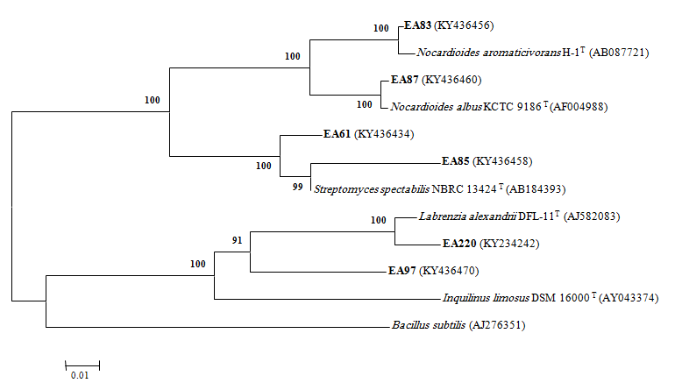

Figure 2. (a) Negative mode LC/MS analysis of Streptomyces sp. (EA61) and (b) Positive mode LC/MS analysis.

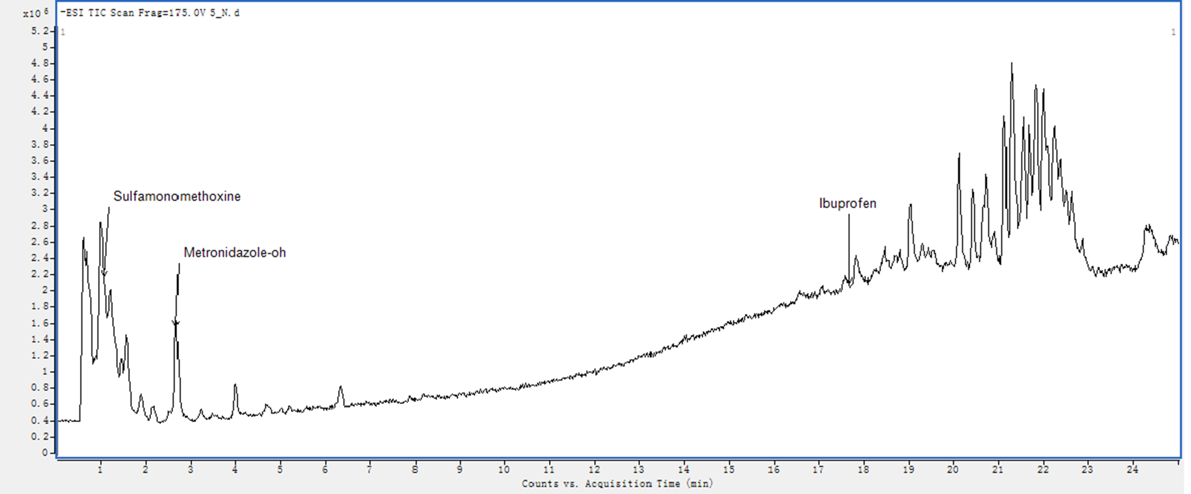
(a)
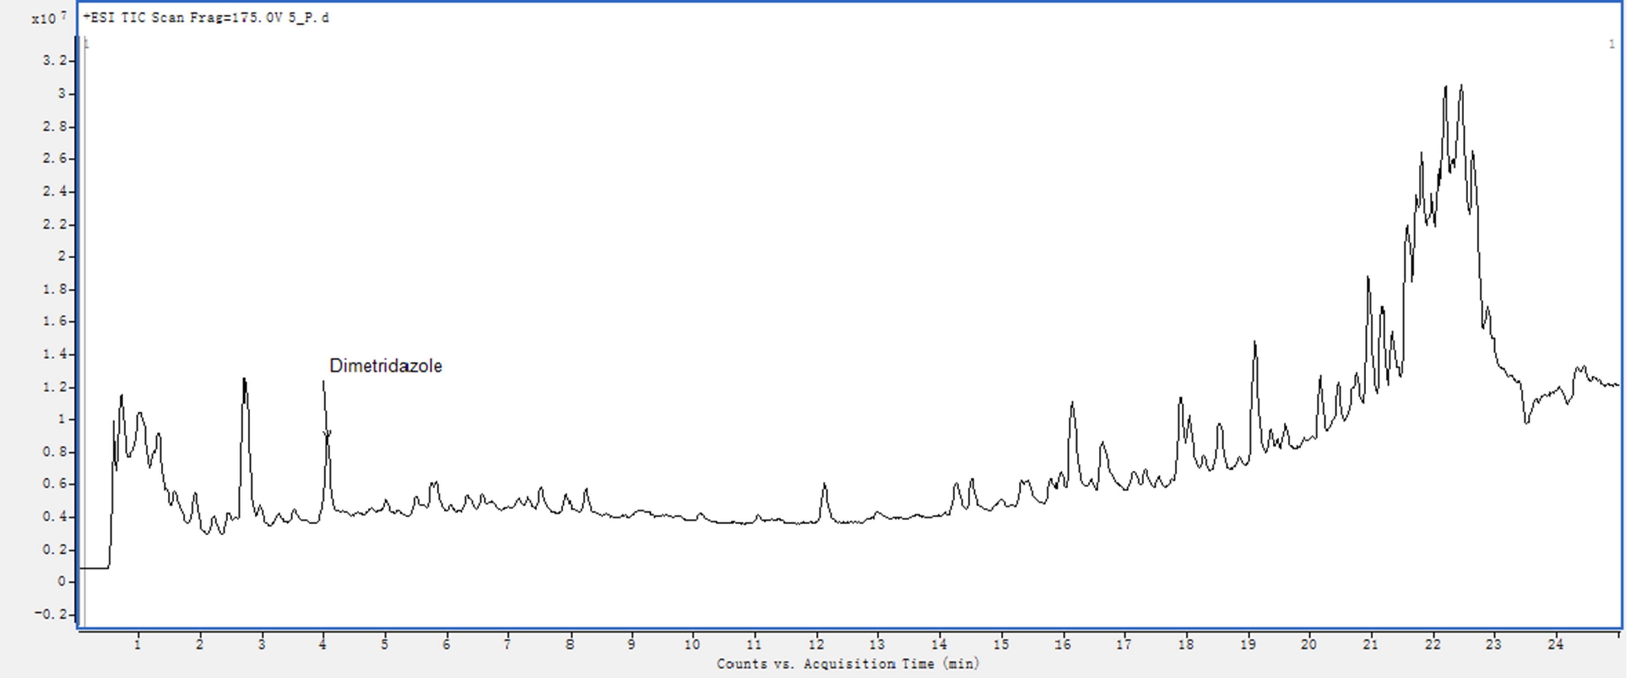
(b)
Figure 3. (a) Negative mode LC/MS analysis of Nocardioides sp. (EA83) and (b) Positive mode LC/MS analysis.
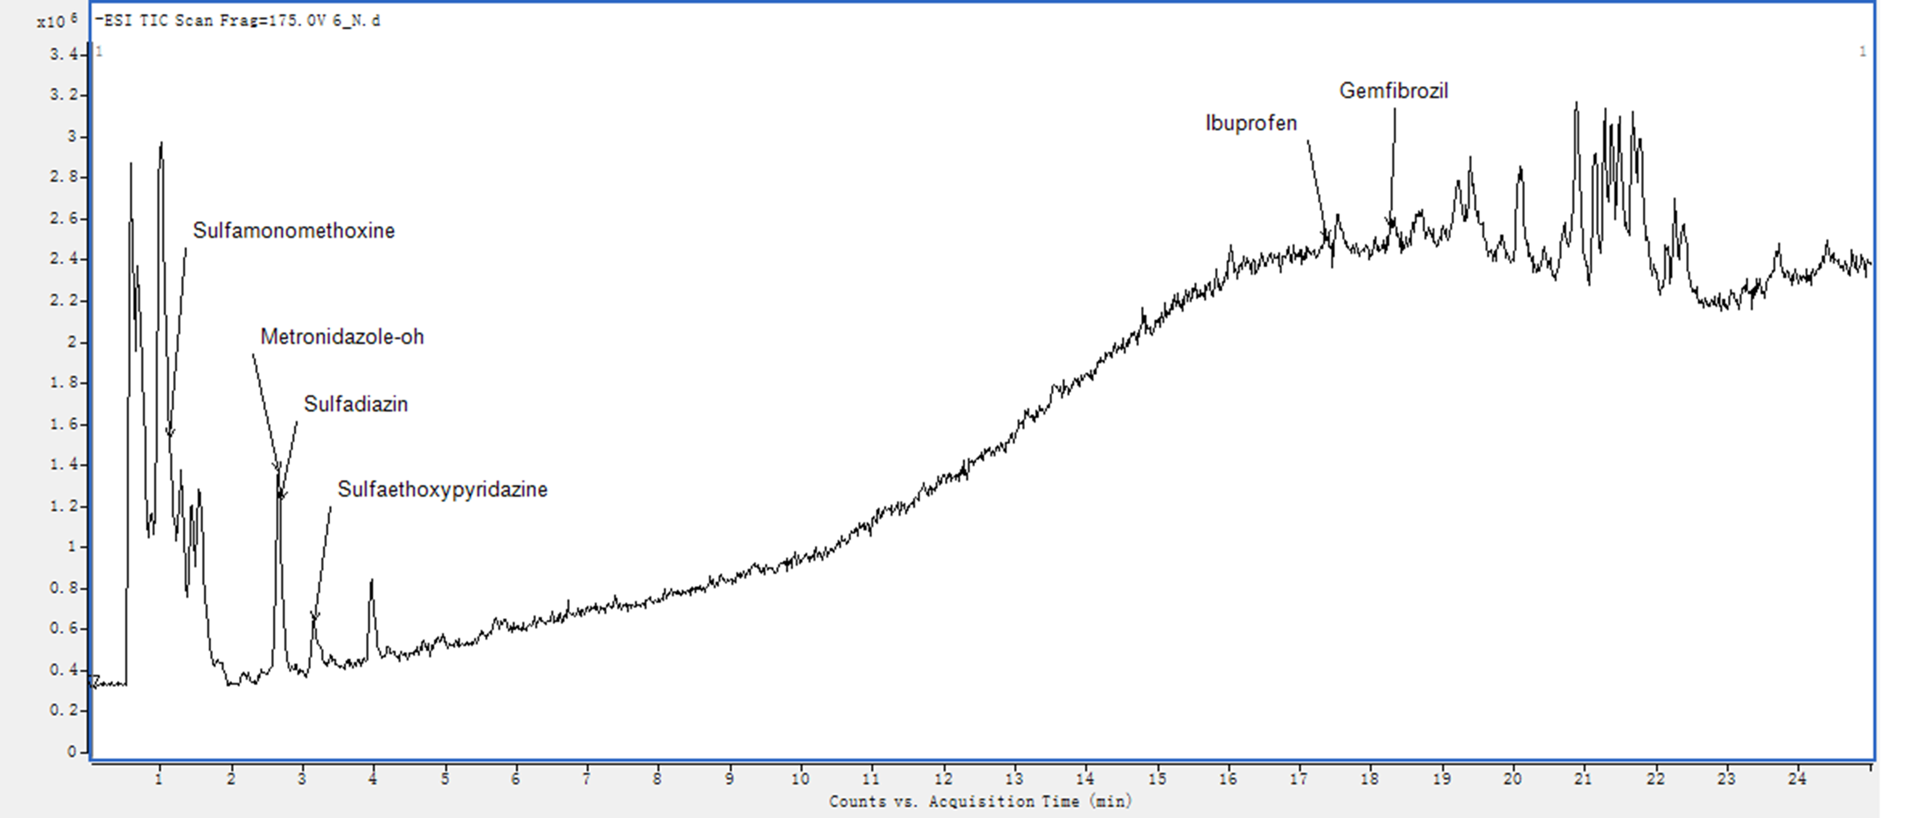
(a)
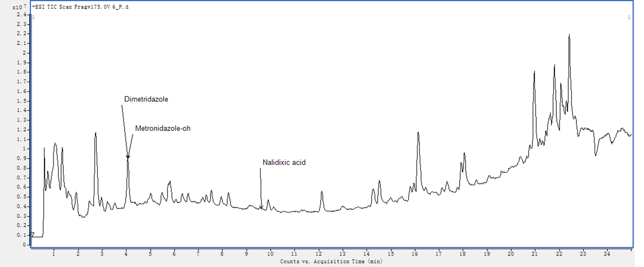
(b)
Figure 4. (a) Negative mode LC/MS analysis of Streptomyces sp. (EA85) and (b) Positive mode LC/MS analysis.
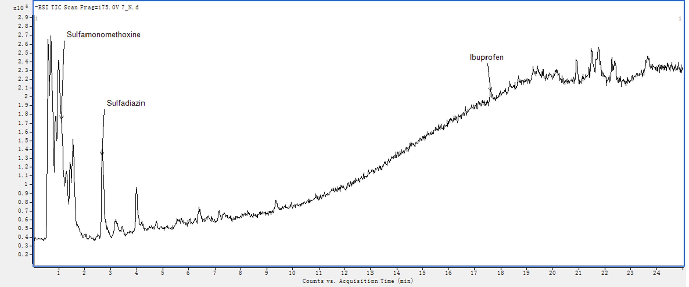
(a)
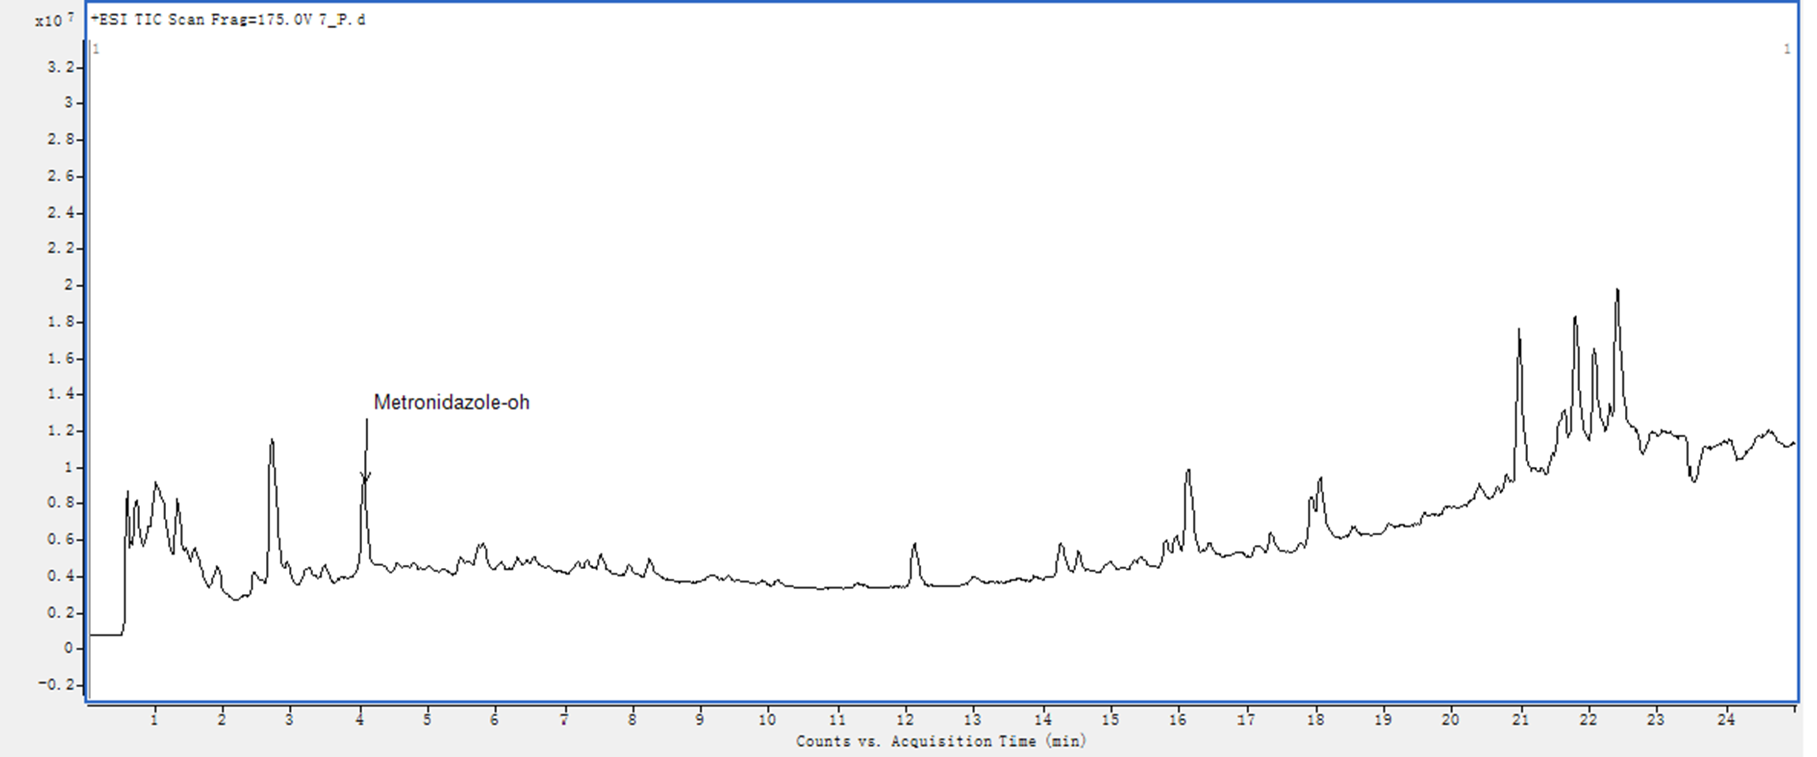
(b)
Figure 5. Negative mode LC/MS analysis of Nocardioides sp. (EA87) and (b) Positive mode LC/MS analysis.

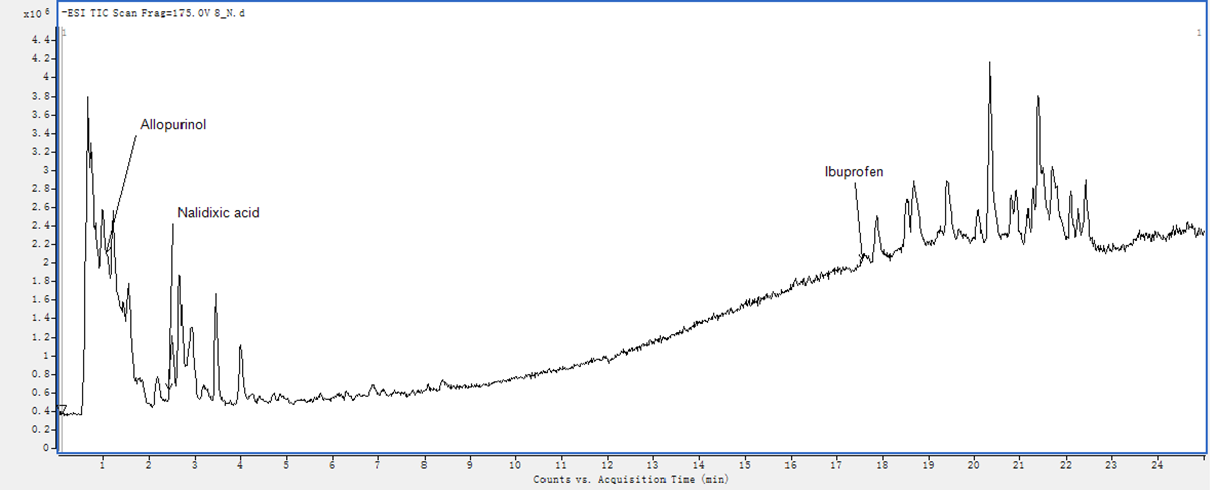
(a)
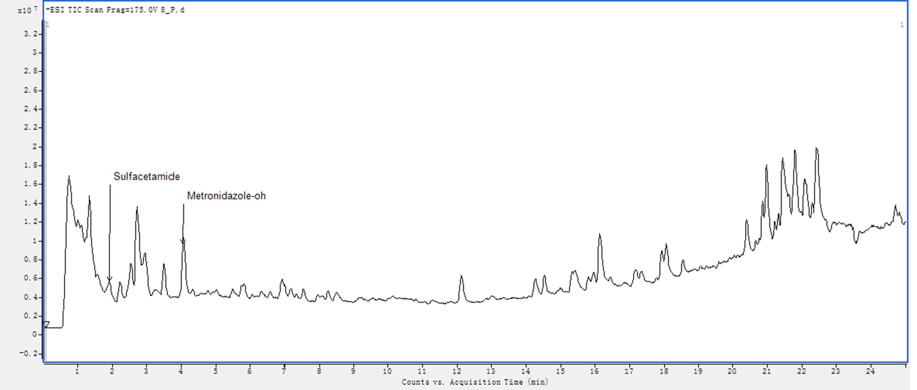
(b)
Figure 6. Negative mode LC/MS analysis of Inquilinus sp. (EA97) and (b) Positive mode LC/MS analysis.
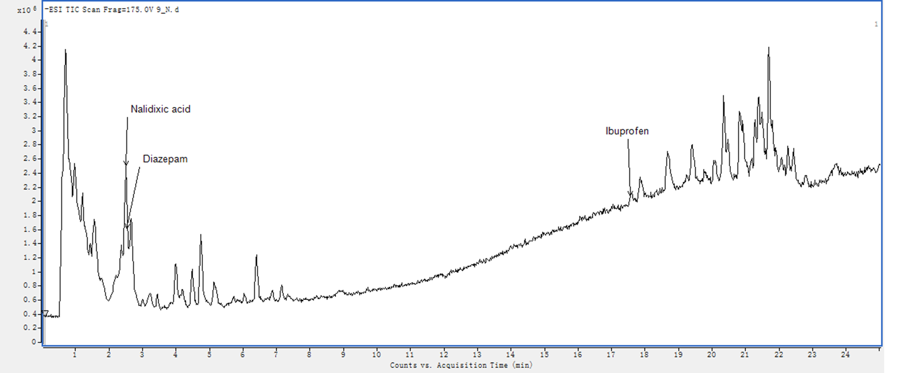
(a)
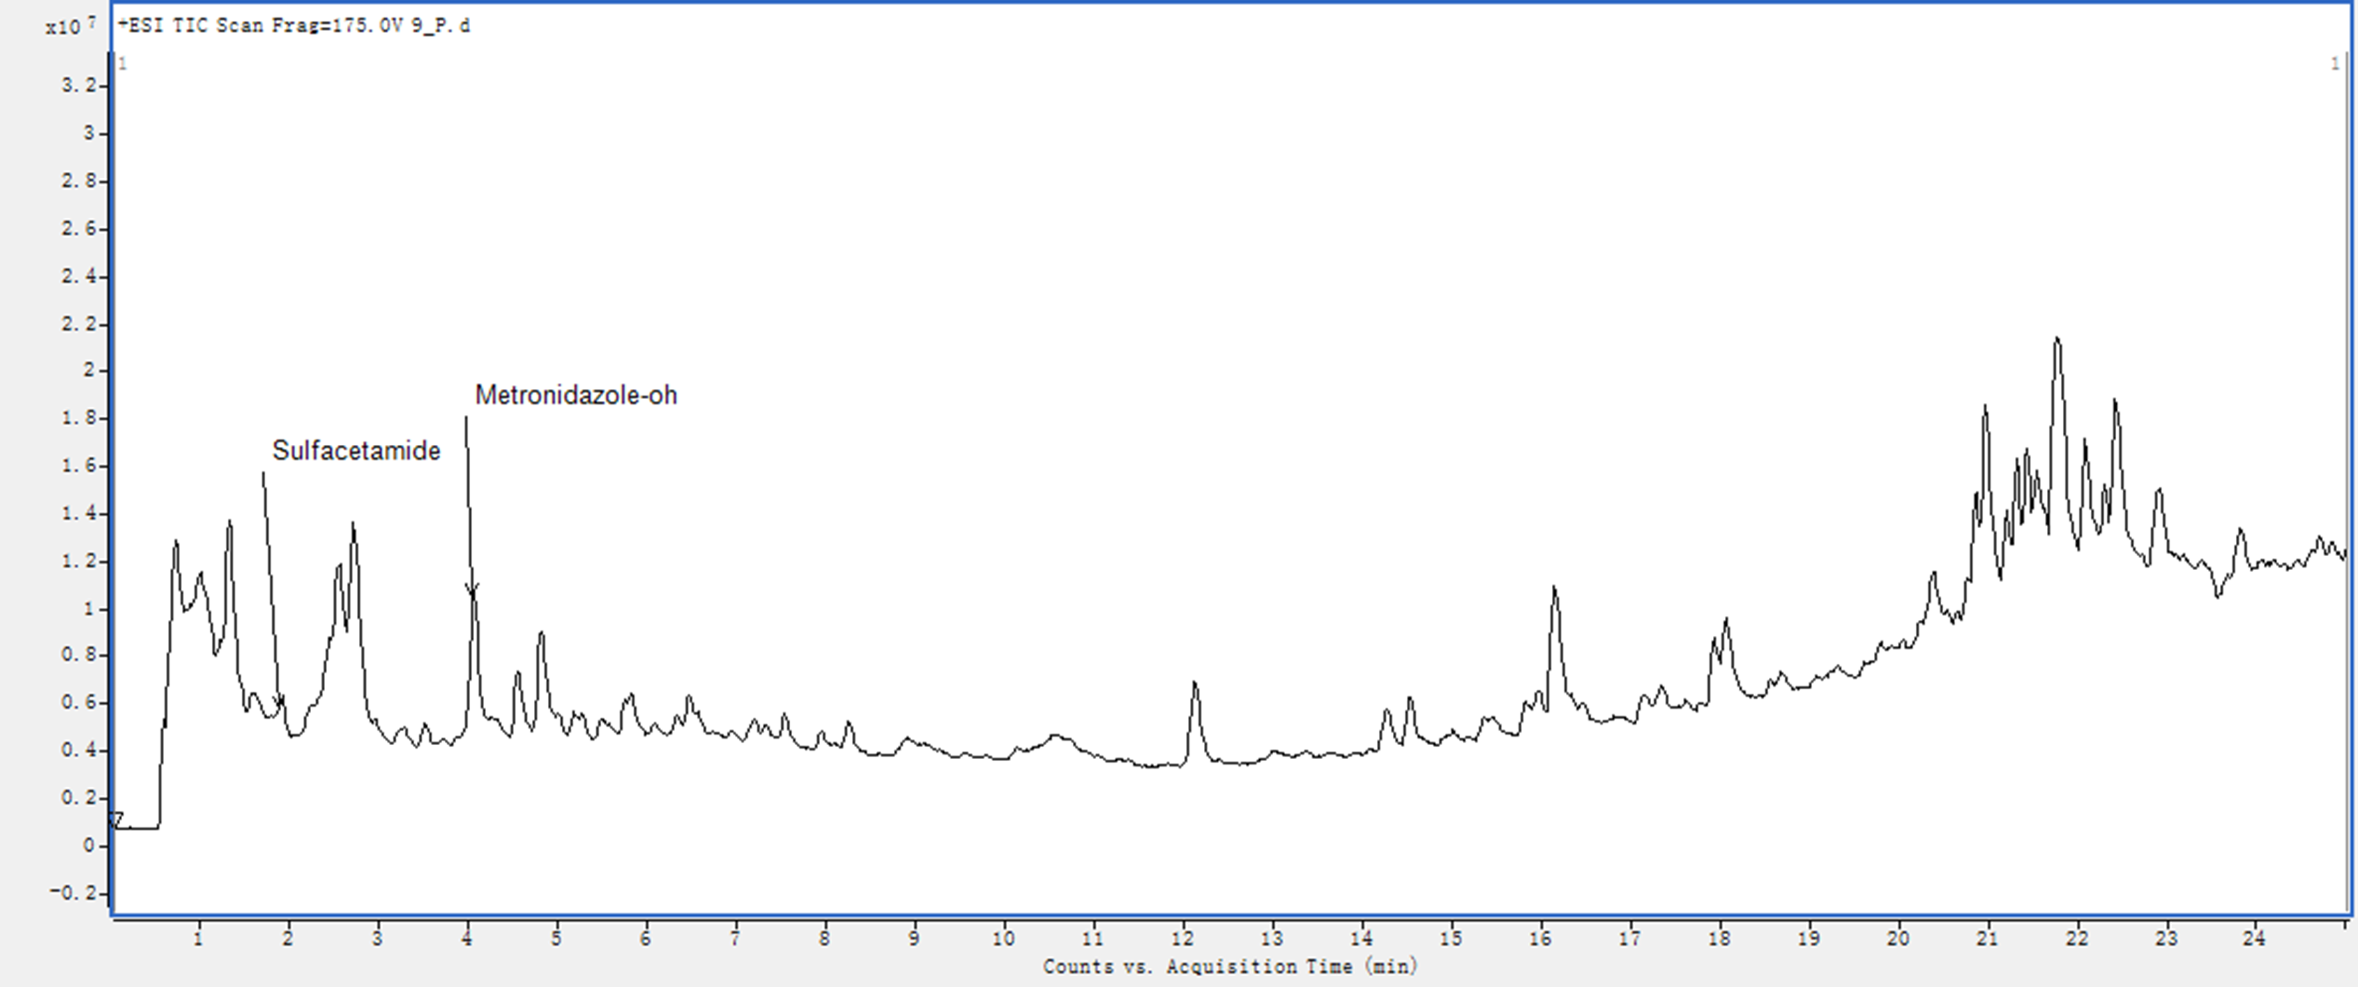
(b)
Figure 7. Negative mode LC/MS analysis of Labrenzia sp. ( EA220) and (b) Positive mode LC/MS analysis.
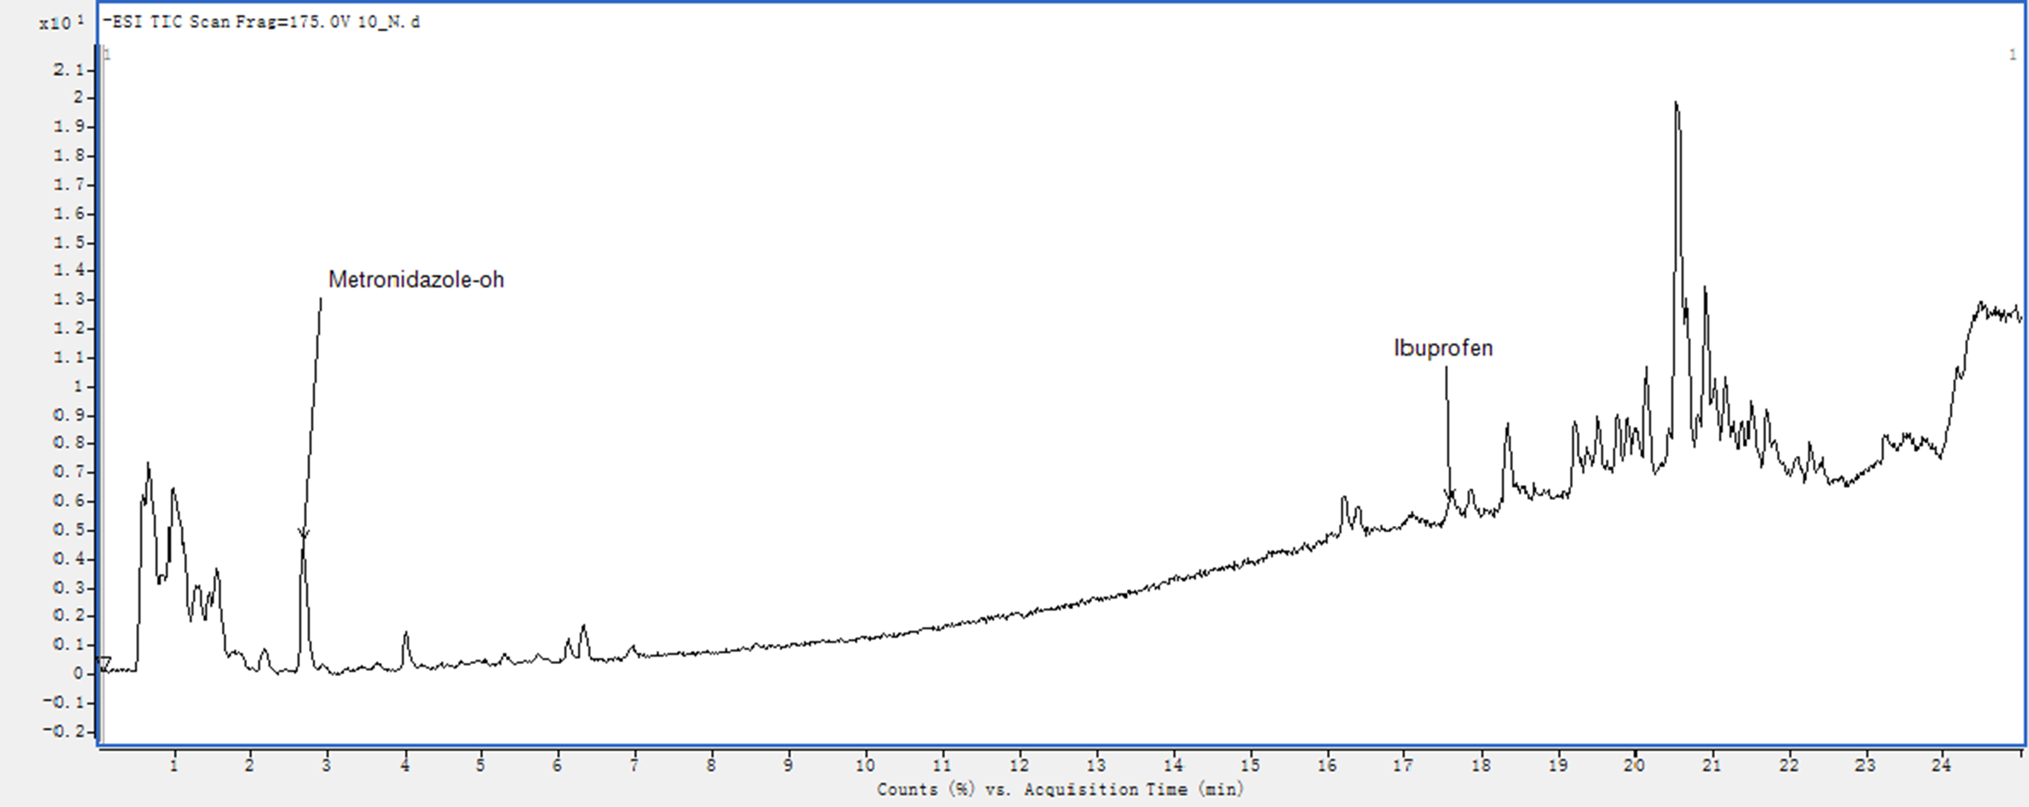(a)

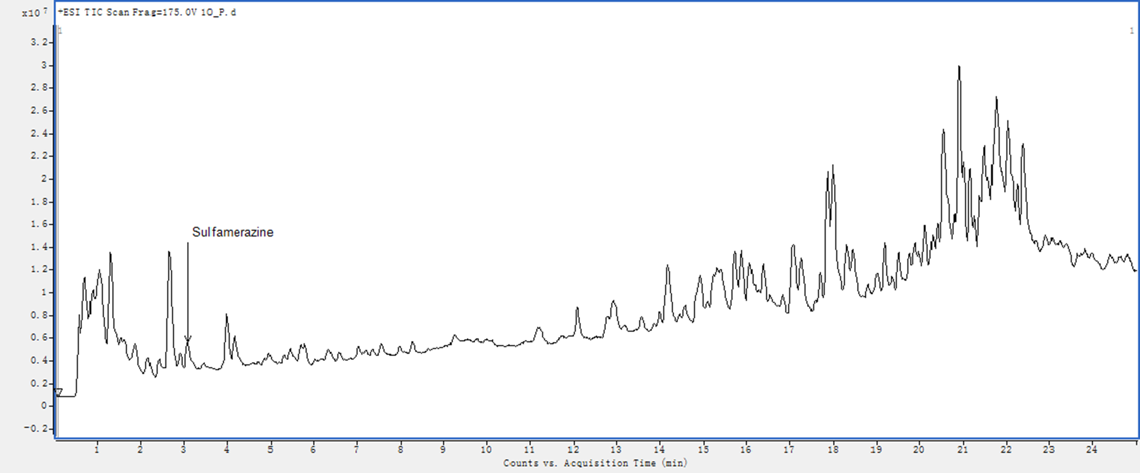(b)
Table 1. Taxonomic identification, antifungal acitivity and enzymes production of rhizo and endophytic bacteria from halophytes.
Lab no | ªClosely related type strain |  | Accession number | ^{b} % identity | Class | P. ultimum | P. capsici | M. grisea | A. mali | F. oxysporum
 | Salsola imbricata
 |  | Roots
EA61 | Streptomyces enissocaesilis NBRC 100763^{T} |  | KY436434 | 99.4 | Actinobacteria | +++ | + | + | +++ | -
 | Avicennia marina
 | Pneumatophores
EA83 | Nocardioides aromaticivorans H-1^{T} |  | KY436456 | 99.4 | Actinobacteria | + | + | - | - | -
EA85 | Streptomyces spectabilis NBRC 13424 ^{T} |  | KY436458 | 95.9 | Actinobacteria | + | ++ | - | - | -
EA87 | Nocardioides albus KCTC 9186 ^{T} |  | KY436460 | 99.1 | Actinobacteria | ++ | + | - | - | -
 | Roots
EA97 | Inquilinus limosus DSM 16000 ^{T} |  | KY436470 | 96.4 | Alphaproteobacteria | +++ | + | + | - | -
 | Haplopeplis perfoliata
 | Roots
EA220 | Inquilinus alexandrii DFL-11^{T} |  | KY234242 | 98.1 | Alphaproteobacteria | + | + | + | - | -

ªIdentification based on partial 16S rRNA gene sequence analyses of all antagonistic bacteria.
^{b}% similarity with closely related type strain
^{c}Antagonistic activity of all bacteria isolated in this study. The activity was measured after 3-5 days incubation at 28°C by measuring the clear zone of mycelial growth inhibition: -, Negative; +, 3 mm; ++, between 4 to 6mm; +++, between 7 to 9mm.

Table 2. Secondary metabolites detected in crude extract of bacteria isolated from halophytes.
No. | Ion mode | ID Source | Name | Formula | RT | Precursor | Mass | Score | Relative Reference Mass difference | Area
 | Strain EA61
1 | Negative | DBSearch | Sulfamonomethoxine | C11 H12 N4 O3 S | 1.12 | 279.0569 | 280.0643 | 87.35 | -4.7 | 209272
2 | Negative | DBSearch | Metronidazole-oh | C6 H9 N3 O4 | 2.692 | 232.0571 | 187.059 | 96.71 | 1.67 | 633292
3 | Negative | DBSearch | Ibuprofen | C13 H18 O2 | 17.591 | 265.1451 | 206.1309 | 89.31 | -1.02 | 898447
4 | Positive | DBSearch | Dimetridazole | C5 H7 N3 O2 | 4.061 | 159.0879 | 141.0531 | 75.73 | 5.19 | 1044068
 | Strain EA83
5 | Negative | DBSearch | Sulfamonomethoxine | C11 H12 N4 O3 S | 1.112 | 279.0555 | 280.0629 | 76.23 | 0.46 | 128199
6 | Negative | DBSearch | Metronidazole-oh | C6 H9 N3 O4 | 2.661 | 232.0568 | 187.0586 | 95.49 | 3.59 | 673424
7 | Negative | DBSearch | Sulfadiazin | C10 H10 N4 O2 S | 2.673 | 249.0463 | 250.0538 | 85.56 | -5.4 | 225564
8 | Negative | DBSearch | Sulfaethoxypyridazine | C12 H14 N4 O3 S | 3.158 | 293.0718 | 294.0794 | 90.29 | -2.59 | 173652
9 | Negative | DBSearch | Ibuprofen | C13 H18 O2 | 17.346 | 265.1448 | 206.1304 | 86.87 | 1.19 | 514480
10 | Negative | DBSearch | Gemfibrozil | C15 H22 O3 | 18.289 | 309.1704 | 250.1565 | 83.38 | 1.68 | 204221
11 | Positive | DBSearch | Dimetridazole | C5 H7 N3 O2 | 4.061 | 159.0878 | 141.0539 | 47.56 | -0.69 | 897920
12 | Positive | DBSearch | Nalidixic acid | C12 H12 N2 O3 | 9.72 | 233.0923 | 232.085 | 86.9 | -0.87 | 567512
 | Strain EA85
13 | Negative | DBSearch | Sulfamonomethoxine | C11 H12 N4 O3 S | 1.115 | 279.0565 | 280.064 | 88.74 | -3.53 | 328203
14 | Negative | DBSearch | Sulfadiazin | C10 H10 N4 O2 S | 2.677 | 249.0463 | 250.0538 | 85.59 | -5.31 | 290107
15 | Negative | DBSearch | Ibuprofen | C13 H18 O2 | 17.599 | 265.1449 | 206.1307 | 87.71 | -0.05 | 699256
16 | Positive | DBSearch | Metronidazole-oh | C6 H9 N3 O4 | 4.06 | 188.066 | 187.0587 | 91.77 | 3.32 | 17067054
 | Strain EA87
17 | Negative | DBSearch | Allopurinol | C5 H4 N4 O | 1.067 | 135.0308 | 136.0381 | 85.77 | 2.83 | 623417
18 | Negative | DBSearch | Nalidixic acid | C12 H12 N2 O3 | 2.501 | 277.0835 | 232.0849 | 87.24 | -0.56 | 1163972
19 | Negative | DBSearch | Ibuprofen | C13 H18 O2 | 17.595 | 265.1452 | 206.131 | 88.46 | -1.5 | 790367
20 | Positive | DBSearch | Sulfacetamide | C8 H10 N2 O3 S | 1.807 | 215.0478 | 214.0405 | 75.53 | 3.14 | 1181016
21 | Positive | DBSearch | Metronidazole-oh | C6 H9 N3 O4 | 4.063 | 188.0667 | 187.0596 | 94.09 | -1.36 | 21182800
 | Strain EA97
22 | Negative | DBSearch | Nalidixic acid | C12 H12 N2 O3 | 2.494 | 277.0833 | 232.0848 | 87.87 | -0.03 | 1819479
23 | Negative | DBSearch | Diazepam | C16 H13 Cl N2 O | 2.526 | 283.0655 | 284.0731 | 61.02 | -4.99 | 337634
24 | Negative | DBSearch | Ibuprofen | C13 H18 O2 | 17.588 | 265.1453 | 206.1311 | 86.08 | -2.1 | 815052
25 | Positive | DBSearch | Sulfacetamide | C8 H10 N2 O3 S | 1.809 | 215.0485 | 214.0414 | 93.75 | -0.72 | 1278958
26 | Positive | DBSearch | Metronidazole-oh | C6 H9 N3 O4 | 4.066 | 188.0673 | 187.06 | 89.3 | -3.79 | 21453990
 | Strain EA220
27 | Negative | DBSearch | Allopurinol | C5 H4 N4 O | 1.057 | 135.0308 | 136.0381 | 85.64 | 2.92 | 491705
28 | Negative | DBSearch | Diazepam | C16 H13 Cl N2 O | 2.02 | 283.0658 | 284.0731 | 61.81 | -5.31 | 293775
29 | Positive | DBSearch | Oxibendazole | C12 H15 N3 O3 | 3.513 | 250.1195 | 249.1122 | 95.63 | -3.57 | 483436

