Potential Protective Effect of Vitamin D on Cardiac Apoptosis in Male Wistar Obese Rats

Khadeejah Mesaid Al-Solami^{1*}, Zainab El-Refay¹, Hussam Awad¹, Mahmood Rasool²

1- Department of Physiology, Faculty of medicine, King Abdulaziz University, Jeddah, Saudi Arabia.
2- Center of Excellence in Genomic Medicine Research, King Abdulaziz University, Jeddah, Saudi Arabia.

*- Corresponding Author:

Khadeejah Mesaid Al-Solami,
Department of Physiology, Faculty of medicine, King Abdulaziz University, Jeddah, Saudi Arabia
Email: khadeejahalsolami@gmail.com

Abstract
Background: Obesity and vitamin D deficiency are increasing in Kingdom of Saudi Arabia (KSA) in last decades. Researchers have shown a relation between both disorders and cardiovascular disease (CVD). The present work aimed to investigate the possible protective effect of vitamin D on cardiac apoptosis in rats fed with a high fat diet.
Methods: This study included 30 male wistar rats and was divided in four groups. One group fed standard diet [control (C)], second group fed standard diet with vitamin D, third group fed hypercaloric diets [obese (Ob], and fourth group fed hypercaloric diets with vitamin D, for 22 weeks. The weight and length were measured to assess BMI and repeated every 45 days. Food intake and body weight were monitored. Heart tissues were collected for Quantitative Real-time polymerase chain reaction (qRT-PCR) to detect different genetic markers of apoptosis (BCL2, BAX, FAS, FAS-L, TNF, MAPK).
Results: A significant increase in FAS, FAS-L, Bax, TNF, MAPK gene expression in rats fed with high fat diet was found. Bax gene expression was highly significantly decreased in rats fed with high fat diet supplied with vitamin D.
Conclusion: The cardiac apoptotic pathways were activated in rats fed with high fat diet. It was found that vitamin D protects the heart from the cardiac apoptotic pathway.
Key Words: Apoptosis, Heart, Obesity, Vitamin D.

Introduction
Obesity is defined as an excessive amount of body fat in relation to lean mass that compromises healthy individuals (Lopaschuck et al., 2007). It could lead to comorbidities such as type 2 diabetes mellitus, dyslipidemias, hypertension, stroke and coronary artery disease.(Gordon et al., 1976; Bjorntorp et al., 1987). Moreover, obesity has been also well known as an independent risk factor for cardiovascular disease (Hubert et al., 1983).
Although it is clear that genetic factors could contribute obesity in an individual, however, the over intake of high calorie food may develop a positive vitality stability and cause the advancement of overweight and obesity condition (Swinburn et al., 2002). There has been conflicting reports related with association of cardiac function and obesity in the scientific literature.
In Saudi Arabia, studies report a constant increase in the prevalence of obesity in the last 3 decades. From late 1980s till mid-1990s, overall prevalence of obesity was estimated at 20% (13.1% in men and 26.6% in women). From 1995 till the last national survey of 2005, in collaboration with world health organization (WHO), all estimates were above 35%. (Kang et al., 2015; Dyson et al., 2014) Since then, national measures have been taken by the Saudi Ministry of Health (SMOH) to control the expansion of the epidemic. However, no further national studies have been conducted to assess the efficacy of these measures, until 2013.(Memish et al., 2014).
In 2013, Memish et al.,(2014) conducted a survey with comparable design to the 2005 national survey. They reported significant decrease in the prevalence rates, in comparison with those recorded in the last national survey of 2005 and those estimated for 2010. As per Memish et al.,(2014) from 2005 to 2013, men’s and women’s obesity decreased by 4.4% and 10.7%, respectively. Additionally, data from Memish et al., (2014) suggested an increase in the proportion of men and women with normal BMI: + 7.8% and +9.0%, respectively (Memish et al., 2014).
However, with regards to age group, data from Memish et al.,(2014) demonstrated that the falling trend in prevalence of obesity, from 2005 to 2013, concerned the younger categories of age (<35 years in men and <55 years in women), in comparison with the older categories of ages where the trend was in rise. Regardless this repartition, the significant decrease of obesity in Saudi Arabia is a good reflect of the efficacy of local health measures and policy to control the obesity, and the awareness campaigns undertaken by the SMOH, over the last decade, which focused on dietary and behavioral adjustments (Memish et al., 2014). Human obesity is characterized by low serum 25-hydroxyvitamin D3levels. (CPEarthman etal., 2012). The correlation between obesity and vitamin D level is unknown.
Vitamin D deficiency has been shown to be highly prevalent among general population. and anoviated with various chronic diseases including CVD which might be a leading cause of death.(Assalin et al.,2013).
Even though Saudi Arabia has dry sunny climate all round the year. The populace barely exposes themselves to direct sunlight. In a study carried out by Ardawi etal, (Ardawi et al., 2012) deficiency of vitamin D was present in 87.8% and vitamin D insufficiency was present in 9.7% in Saudi Arabian men. Also, Aldahr etal, (Aldahar et al.,1991) study was conducted at KAU hospital in jeddah, observed that 80% of children and adolescents patients, had vitamin D deficiency while 3.5% of them were vitamin D insufficient. likewise, a study carried out in jeddah by Siddique et al.,(2007) that involved 600 adolescent female students revealed low vitamin D levels among 81% and very low levels among 40% of the participants.
Gardner et al., (2011) reported a critical role played by vitamin D in cardiovascular framework. At recent time, heart and vasculature have been recognized as possible focuses of vitamin D activity, a developing assortment of confirmation recommends that the activated VDR take a crucial part in managing cardiovascular activity.(Gardner et al.,2011).Various epidemiological and clinical investigations have revealed a close relationship among hypovitaminosis D and cardiovascular disease (CVD). Scragg et al.,(1990) detailed an reverse connection among the levels of serum 25(OH)D and myocardial localized necrosis in a group setting. Martin et al.,( 2007) revealed a plausible connection amidst hypovitaminosis and main CVD hazard components, such as overweight, hypertension, diabetes, hypertriglyceridemia (however, not hyper-colesterolemia, following alteration for various variables. Moreover, various investigations have demonstrated that hypovitaminosis D is an indicator of cardiovascular and all-cause death, autonomous of the conventional hazard variables.(Wang et al., 2008;Dobnig 2008). Thus, an evaluated reverse connection amid the levels of serum 25(OH)D and CVD is by all accounts most obvious as levels fall beneath 20 to 25 ng/ml. Additionally, Pfeifer et al.,( 2001) observed a decline in blood pressure, heart rate and levels of parathyroid hormone in aged women following interim dispensation of 800 IU of 25(OH)D with 1200 mg calcium against 1200 mg/d calcium singly. This finding indicates that insufficient consumption of 25(OH)D and calcium could assume a conducing part in the pathogenesis and advancement of hypertension and CVD.
Despite several studies showing that a VD-deficient diet induces cardiac changes, the influence of the length of VD restriction on cardiac tissue is unknown. In addition, the mechanisms involved in this process remains to be elucidated. The series of events, beginning from an irreversible injury ultimately leading to death of cardiomyocytes, that are mediated via an intracellular programmed cell death pathway termed as apoptosis. (S.Elmore et al.,2007; J.H.Zhang etal.,2000). Apoptosis is characterized by a series of morphological and physiological alterations that are well coordinated and triggered at a precise time, which ultimately leads to presentation of key hallmarks of apoptosis via DNA fragmentation, DNA condensation, cellular shrinkage and formation apoptotic bodies.( S.Elmore et al.,2007; J.H.Zhang etal.,2000).
During the apoptotic process, the severely damaged or dead cells are removed in a coordinated manner in such a way that the neighboring cells remain unharmed from the unwanted and potentially hazardous cellular materials (E.F.Mason et al., 2011). Although the apoptotic process involving the controlled removal of damaged cells is beneficial for the heart, accelerated rates of cardiomyocyte apoptosis has been observed in certain cases of cardiovascular diseases. (K.M.Kurrelmeyer et al., 2000; R.S.WWhelan et al., 2010). Cardiomyoctes are terminally differentiated cells and thus cannot be replaced in a short duration in case of extensive cellular damage (P.P.Rumyantsev et al., 1977). Therefore, in an event of an increased cardiomyocyte death via apoptosis as a result of an injury to the myocardial tissues, it can ultimately lead to major impairment of the cardiac function (R.S.WWhelan et al., 2010). It is known that AMPKs are key regulators of apoptosis. MAPKs (Mitogen-activated protein kinases) are serine/threonine kinases that are evolutionarily conserved which regulate the cellular behavior including survival, growth, and differentiation by altering protein function and gene expression in response to specific extracellular cues (R.S.Whelan et al., 2010).
Activation of the MAPKs signaling pathways results in the secretion of tumor necrosis factor (TNF-α), a potent pro-inflammatory cytokine, from the monocytes and macrophages. It was the first inflammatory mediator linked with complication of besity. (Chen et al., 2002; De Luca et al., 2006).

Method:
Male wistar rats weighing 150-200 g were housed under standard laboratory conditions at temperature (23 ± 3 ⁰C) and natural 12 hours light/dark cycle with free access of water ad libitum. All animals were kept under conditions that prevent them from experiencing unnecessary pain and discomfort according to guidelines approved by the institutional ethical committee. They were randomly assigned to receive either the standard diet as a normal control rats or high-fat diet rats.
Experimental protocol:
Total 30 rats were included in this study. After one week of acclimatization, the rats were divided into the following groups:
Group I: Normal control rats (n = 5) received the standard rat chow.
Group II: Standard rat chow – vitamin D treated rats for six months ( n = 5 ).
Group III: High Fat diet rats for six months ( n = 10 ).
Group IV: High Fat diet – vitamin D treated rats for six months ( n = 10 ).

The standard rat chow (D12450 H; research diet center) contains 10 %fat, 70% carbohydrate and 20% protein. The high Fat diet (D12451; research diet center) contains 45% kcal fat, 35% carbohydrate and 20% protein (Burgmair et al., 2010). Vitamin D were used by gavaging technique in a dose of 400 IU/kg/day (Vieth et al., 2004). The weight and length were measured to asses BMI at the beginning of study and repeated every 45 days. Food intake and body weight were monitored throughout the study period.
At the end of the experimental period, the rats were sacrificed under diethyl ether and the heart were excised and washed with normal saline 0.9% and dried by filter paper. Some heart specimens from different groups were prepared for PCR assessments.
RNA Extraction
Total RNA was isolated from the cells using column purification technology by RNeasy Mini Kit (Qiagen). Separation of RNA was carried out according to the manufacturer‘s instructions (Qiagen).
RT-PCR
Total RNA was reverse transcription of RNA to complementary deoxyribonucleic acid (cDNA) was prepared using cDNA reverse transcription kit (ImProm-II™ Reverse Transcription System cat no. A3800).
Then cDNA amplified by the polymerase chain reaction using using the KAPA SYBR® FAST qPCR Kit Master Mix (2X) Universal Cat no. KR0389.
Amplimers were synthesized by MdBio, Inc., based on cDNA sequences from Gen Bank. The rat glyceraldehyde 3-phosphate dehydrogenase (GAPDH) was used as an internal standard. The following rat primers were used: rat Bcl2 forward primer- AGTGGGATACTGGAGATG: rat Bcl2 reverse primer CTGGCTGTCTCTGAAGAC;
rat FAS forword primer CTGATAGCATCTCTGAGG: rat FAS reverse primer-CTGATAGCATCTCTGAGG; rat FAS-L forward primer-GACAACATAGAGCTGTGG: rat FAS reverse primer- GACAACATAGAGCTGTGG; rat MAPK forward primer TGAGAACATCATCGGCATC; rat MAPK reverse primer GCACCTCAGCAATGATCA; rat TNF forward primer CTTCTGTCTACTGAACTTCG; rat TNF reverse primer CCAATGGCATGGATCTCAA.
Statistical Analysis
The data were compared between lean and obese groups using Student’s t test for two independent samples, and paired t- test for two dependent samples. ANOVA test and prism program used in all cases, a difference at P< 0.05 was considered statistically significant.

Results
Body weight of rat fed experimental diets
No significant difference in body weight or BMI was observed between groups at the end of the 6 month study period.
BAX and BCL2 polypeptides
The mitochondrial-dependent apoptotic pathway was assessed through measuring expression of the anti apoptotic BCL2 and pro apoptotic Bax proteins. BAX was less expressed in C+VD but significantly expressed in HFD and HFD+VD compared with control. BAX was significantly down regulated in C vs C+VD, and HFD vs HFD+VD. At 6 months period BCL2 was down regulated in all groups compared with control and was significantly down regulated in C+VD but when compare groups with C+VD, there was up regulation of BCL of HFD+VD, also HFD+VD up regulated when compare with HFD (Figure 1).

FAS, FAS-L polypeptides:
The components of cardiac extrinsic apoptotic signaling pathways were studied. At 6 months period FAS was up regulated in all groups compared with control while was significantly up regulated in HFD, and FASLG was significantly down regulated in C+VD while slightly up regulated in HFD and HFD+VD with respect to control (Figure1, 2).
Tumor necrosis factor- 𝛼 (TNF-𝛼):
At 6 months period TNF was slightly high in HFD+VD group but was significantly up regulated in HFD compared with control (Figure 2).
MAPK :
At 6 months period MAPK1 was slightly low in C+VD case and slightly high in HFD+VD but was significantly up regulated in HFD compared with control (Figure 2).

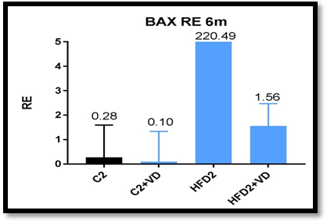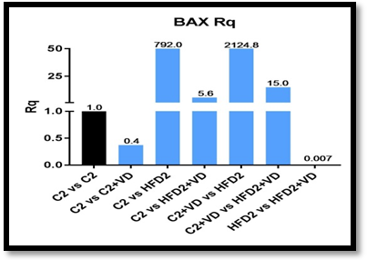

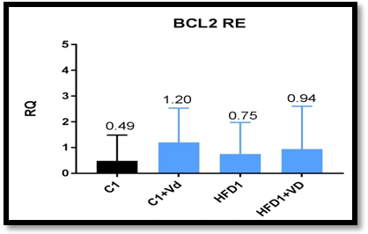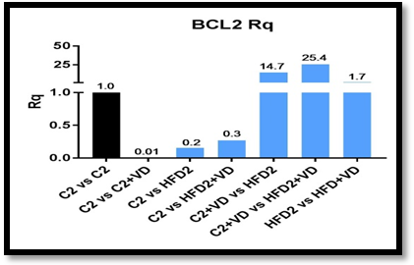
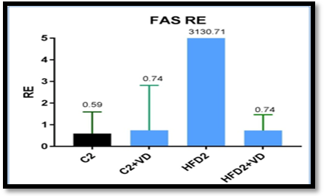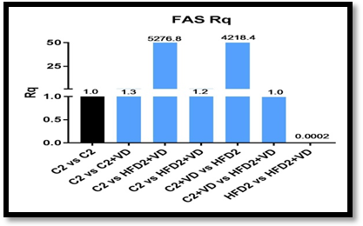

Figure 1: Expression of BAX, BCL2, FAS. bars represent the relative quantification indicate mean ± SD

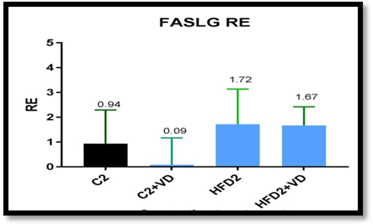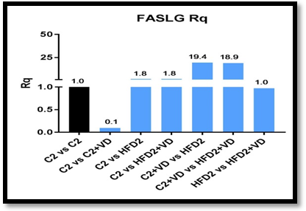
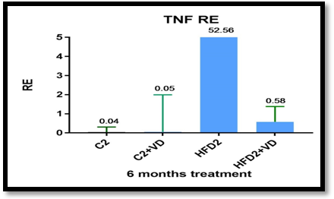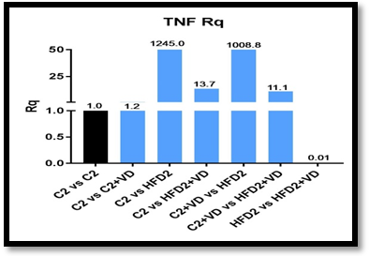

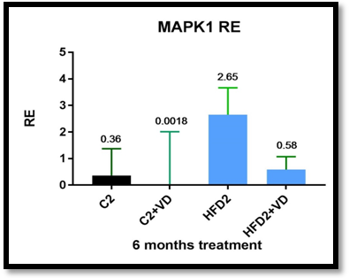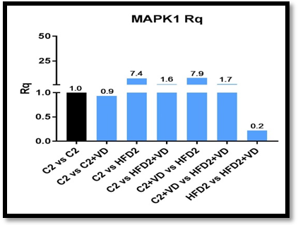

Figure 2: Expression of Fas-L, TNF-𝛼, MAPK1. bars represent the relative quantification indicate mean ± SD.

Discussion:

The majority of the results show that there is a strong correlation between the increased cardiac apoptosis and high fat diet. Lipid-induced cardiac dysfunction has been attributed for the increase in apoptosis resulting from the disruption of key cellular pathways due to endoplasmic reticulum (ER) stress (N.M. Borradaile et al., 2006) and mitochondrial dysfunction. Various molecules such as reactive oxygen species (ROS)( N.M.Borradaile et al.,2006), ceramide (Y.T.Zhou et al., 2000), PPAR nuclear receptors ligands(Y. Lee et al., 2004), phosphatidylinositol-3-kinase(S. Hardy et al., 2000 ), nitric oxide (NO)( M. Shimabukuro et al.,1997), leptins (Y. Lee et al.,2006), and other adipokines(R. Palanivel et al., 2008) have been implicated for their role in promoting these lipotoxic effects.
In current study, the BAX gene was highly expressed in cardiac tissue in the obese rats. Our findings, therefore, clearly suggests that obesity in wister rats leads to activation of cardiac mitochondria-dependent apoptotic pathway that in turn enhances the risk of developing cardiac apoptosis. In our result, there was an up regulation of BCL2 and down regulation of BAX in rats fed with high fat diet treated with vitamin D, which indicates the protective effect of vitamin D on the cardiac tissue.
Our findings are further corroborated by the report of Cheng et al.,(2013), which shows induced cardiomyocyte apoptosis in hamsters fed with high fat diet for 8 weeks, and also show simultaneous increase in the levels of pro-apoptotic proteins BID and BAX, whereas the levels of anti-apoptotic protein BCL2 was found to be decreased. Furthermore, the findings of Zhu et al.,(2007) showed that 12 weeks of high fat diet elevates the cardiac expression of BAX whereas a decrease in the expression of BCL2 was observed.
The effects of high fat diet on BAX expression extended beyond heart to the vascular smooth muscles cells where Perales et al., (2009) in their in vitro study observed that addition of 25-hydroxycholesterol to cell culture of chicken led to upregulation of BAX expression exposed to high fat diet. Wang et al., (2013) have shown that cardiomyocyte apoptosis is induced by Isoproterenol (ISO) stimulation; Cardioprotective role of vitamin D associated with the reduction of the elevated levels of Bax and caspase-9 induced by ISO indicates that calcitriol (CAL) inhibits apoptosis by modulating the proteins that play critical role in the mitochondrial apoptosis pathway.
In the present study, we observed that during obesity, Fas ligands are elevated in the cardiac tissues that subsequently leads to a significant increase in Fas receptor-dependent apoptotic pathway. In conclusion, our results clearly demonstrate that the obese wistar rats show enhanced activation of Fas receptor-dependent apoptotic pathway in the cardiac tissues. This finding is in line with the previous research of Da Lee et al., (2007) which elucidated that the extractions from heart’s left ventricle of the obese rats contained higher concentration of Fas ligands, Fas receptors, and FADDs as compared to that observed in lean rats.
The research of Zeng et al., (2017) showed that diabetic cardiomyopathy (DCM) rats exhibits elevated mRNA and protein expression levels of Fas and FasL. Subsequent treatment of the DCM rats with vitamin D led to down-regulation of the Fas and FasL, at mRNA and protein levels. These results suggest that treatment with vitamin D can potentially reduce the risk of myocardial apoptosis in DCM rats by lowering the Fas and Fas-L expression levels in the heart tissues. Higher amounts of triacylglyceride (TAG) derived FFAs present in the cellular mileu, resulting from an increase in lipolysis due to obesity, can lead to activation of inflammatory pathways. (Sethi et al., 2007), White adipose tissue (WAT) releases certain bioactive substances such as interleukin IL-1β, (IL)-6, leptin, TNF-α, and adiponectin, and they are collectively termed as adipokines.
White adipose tissue (WAT) comprises of several metabolically active and inflammatory cells, including macrophages. Macrophages originating from the adipose tissues are classified on the basis of the expression of surface markers and/or by the secretion profile of the respective chemokine and cytokine. The number and phenotype of adipose tissue macrophages is observed to be altered in genetic and diet induced obesity. Classically, activated M1 macrophages are present in greater proportion during obesity whereas M2 macrophages, that are required for inflammation resolution, are present in lesser proportion. (Lumeng et al., 2007) Pro-inflammatory cytokines IL-6, IL-1β and TNF-α, are secreted by the M1 macrophages; whereas anti-inflammatory cytokines including IL-10 and IL-1 receptor antagonist (RA) are secreted by the alternatively activated M2 macrophages. (Lumeng et al., 2007). Our results show that TNF is highly expressed in high fat diet group but with treatment of vitamin D the value decreased towards the control group. And MAPK expression increased with HFD group but after treatment with vitamin D it decreased towards the normal control group. Studies from an independent group revealed that knockout of TNFR1 attenuated apoptosis in a permanent ligation model (T. Hamid et al., 2009).
AMPK has been implicated to have a pro-apoptotic effect on the cells other than the cardiac cells like liver cells, vascular smooth muscle cells and pancreatic tumor cells.( D.Meisse et al., 2002; M.lgata etal., 2005; B.A.Kefas et al.,2003). Pro-apoptotic effect of AMPK stems from the activation of caspase- 3 and c-Jun N-terminal kinases (JNK) signaling pathways, (D.Meisse et al., 2002) and the up regulation of the pro-apoptotic protein p53 that inhibits the cell cycle progression. ( M.lgata etal., 2005). It is also reported that ischemia-induced AMPK activation in the neonatal rat cardiomyocytes results in p38 MAPK-mediated translocation of the pro-apoptotic BAX protein from the cytosol to mitochondria which in turn induces apoptosis. (M.Capano et al., 2006).These studies indicates that apoptosis is associated with the AMPK activation.

Conflict of Interest:
The authors declare no conflict of interest.

Reference:
Aldahar S., Mohammad H., Abdul-moein E., Ahmad A, et al. ( 2011). Prevelence of vitamin D deficiency and insufficiency in children and adolescents: four year experience. Australian Journal of Basic and Applied Sciences, 5(11): 1616-1620, ISSN 1991-8178.
Ardawi M., Sibiani A., Bakhsh T., Qari M, et al. (2012). High prevalence of vitamin Ddeficiency among healthy Saudi Arabian men: relationship to bone mineral density, parathyroid hormone, bone turnover markers, and lifestyle factors. Osteoporos Int 23:675–686 DOI 10.1007/s00198-011-1606-1.
Assalin HA. Rafacho B. Santos P. Ardisson L ( 2013). Impact of the length of vitamin D Deficiency on cardiac Remodeling. Circ Heart Fail. 6:809-816.
B.A.Kefas,Yeai,Z.ling.H.Heimberg ( (2003). AMP-activated protein kinase can induce apoptosis of insulin producing MinG cells through stimulation of c-jun-n-terminal kinase, J.Mol.Endocrinol.30:151-161.
Björntorp P. (1987) Classification of obese patients and complications related to the distribution of surplus fat. Am J Clin Nutr. 47:1120-5.
Burgmaier M, Sen S, Philip F, et al. (2010). Metabolic adaptation follows contractile dysfunction in the heart of obese zucker rats fed a high-fat "Western" diet. Obesity (Silver Spring, Md.). 18(10):1895-901.
Chen, G., and Goeddel, D. V. (2002). TNF-R1 signaling: a beautiful path- way. Science 296, 1634–1635.
Cheng YC, Chang MH, Tsai CC, Chen TS. (2013) . Garlic oil attenuates the cardiac apoptosis in hamster-fed with hypercholesterol diet. Food Chem. 136:1296–302.
CPEarthman, LMBeekman, Kmasodkarand, SDsiblay (2012). The link between obesity and low circulating 25-(OH)D concentration:consideration and implications. International journal of obesity 36,387-396.
D.Meisse, M.vandecasteele,c.Beauloye,I.,Hue,Sustained (2002). Activation of AMP-activated protein kinase induces C-junN-terminal kinase activation and apoptosis in liver cells. FEBS Lett.52638-42.
Da lee S. Tzang B., (2007). Cardiac Fas receptor dependent apoptotic pathway in obese Zucker rats. Animal physiology (15)2407.
De Luca, C., and Olefsky, J. M. (2006). Stressed out about obesity and insulin resistance. Nat. Med. 12, 41–42.
Dobnig H, Pilz S, Scharnagl H, Renner W, et al. ( 2008). Independent association of low serum 25-hydroxyvita- min d and 1,25-dihydroxyvitamin d levels with all-cause and cardiovascular mortality. Arch Intern Med 168: 1340– 1349.
Dyson J, Jaques B, Chattopadyhay D, Lochan R, et al. (2014). Hepatocellular cancer: the impact of obesity, type 2 diabetes and a multidisciplinary team. J Hepatol. 60(1):110-7.
E.F. Mason, J.C., (2011). Rathmell, Cell metabolism: an essential link between cell growth and apoptosis, Biochim. Biophys. Acta, Mol. Cell Res. 1813 645–654.
Gardner, D.G., S. Chen, D.J. Glenn & W. Ni (2011). Vitamin D and the Cardiovascular System. In: Vitamin D, 3rd Edition. D.J.W. Feldman, Pike and J.S. Adams, eds: 541–563. Elsevier: New York.
Gordon T, Kannel WB (1976). Obesity and cardiovascular disease: The Framingham Study. Clin Endocrinol Metab. 5:367-75.
H. Fliss, D. Gattinger (1996). Apoptosis in ischemic and reperfused rat myocardium, Circ.Res. 79 949–956.
Hubert HB, Feinleib M, McNamara PM, Castelli WP (1983). Obesity as an independent risk factor for cardiovascular disease: A 26-year follow-up of participants in the Framingham Study. Circulation. 67:968-83.
J. Buchanan, P.K. Mazumder, P. Hu, G. Chakrabarti, et al. (2005). Reduced cardiac efficiency and altered substrate metabolism precedes the onset of hyperglycemia and contractile dysfunction in two mouse models of insulin resistance and obesity, Endocrinology 146 5341–5349.
J.H. Zhang, M. Xu (2000). DNA fragmentation in apoptosis, Cell Res. 10 205–211.
K.M. Kurrelmeyer, L.H. Michael, G. Baumgarten, et al. (2000). Endogenous tumor necrosis factor pro- tects the adult cardiac myocyte against ischemic-induced apoptosis in a murine model of acute myocardial infarction, Proc. Natl. Acad. Sci. U. S. A. 97 5456–5461.
Kang JH, Kang JY ( 2015). Lifestyle measures in the management of gastro-oesophageal reflux disease: clinical and pathophysiological considerations. Ther Adv Chronic Dis. 6(2):51-64.
Lopaschuck GD, Folmes CDL, Stanley WC (2007). Cardiac energy metabolism in obesity. Circ Res.101:335-47.
Lumeng,C.N., Bodzin,J.L.,and Saltiel,A.R (2007).Obesity induces aphenotypic switch in adipose tissue macrophage polarization.J.Clin.Invest.117,175-184.
M. Capano, M. Crompton (2006). Bax translocates to mitochondria of heart cells duringsimulated ischaemia: involvement of AMP-activated and p38 mitogen-activated protein kinases, Biochem. J. 395 57–64.
M. Shimabukuro, M. Ohneda, Y. Lee, R.H. Unger (1997). Role of nitric oxide in obesity- induced beta cell disease, J. Clin. Invest. 100 290–295.
M.lgata,H. Mtoshima,K.Tsuruzoe,k.matsumoto,et al. (2005). Adenosine monophosphate-activated protein kinase suppresses vascular smooth muscle cell proliferation through the inhibition of cell cycle progression,circ.Res.97837-844.
Martins D, Wolf M, Pan D, Zadshir A, et al. ( 1990) .Prevalence of cardiovascular risk factors and the serum levels of 25-hydroxyvitamin D in the United States: Data from the Third National Health and Nutrition Examination Survey. Arch Intern Med 167: 1159 –1165.
Memish ZA, El Bcheraoui C, Tuffaha M, Robinson M, et al.( 2014). Obesity and associated factors--Kingdom of Saudi Arabia, 2013. Prev Chronic Dis. 11:E174.
N.M., (2006). Borradaile, X. Han, J.D. Harp, S.E. Gale, D.S. Ory, J.E. Schaffer, Disruption of endoplasmic reticulum structure and integrity in lipotoxic cell death, J. Lipid Res. 47 2726–2737.
N.M.Borradaile, K.K.Buhman, L.L.Listenberger, C.J.Magee (2006). A critical role for eukaryotic elongation factor 1A-1 in lipotoxic cell death, Mol. Biol. Cell 17 770–778.
P.P. Rumyantsev, (1977).Interrelations of the proliferation and differentiation processes during cardiact myogenesis and regeneration, Int. Rev. Cytol. 51 186–273.
Perales S, Alejandre MJ, Palomino-Morales R, Torres C, et al. (2009). Effect of oxysterol-induced apoptosis of vascular smooth muscle cells on experimental hypercholesterolemia. J Biomed Biotechnol.;2009:456208.
Pfeifer M, Begerow B, Minne HW, Nachtigall D, et al. ( 2001). Effects of a short-term vitamin D(3) and calcium supple- mentation on blood pressure and parathyroid hormone.levels in elderly women. J Clin Endocrinol Metab. 86:1633–1637.
R. Palanivel, V. Vu, M. Park, X. Fang (2008). Differential impact of adipokines derived from primary adipocytes of wild-type versus streptozotocin-induced diabetic rats on glucose and fatty acid metabolism in cardiomyocytes, J. Endocrinol. 199; 389–397.
R.A. Gottlieb, K.O. Burleson, R.A. Kloner, B.M. Babior, et al. (1994). Reperfusion injury induces apoptosis in rabbit cardiomyocytes, J. Clin. Invest. 94 1621–1628.
R.S. Whelan, V. Kaplinskiy, R.N. Kitsis (2010).Cell death in the pathogenesis of heart disease: mechanisms and significance, Annu. Rev. Physiol. 72 19–44.
S. Elmore (2007). Apoptosis, a review of programmed cell death, Toxicol. Pathol. 35.495–516.
S. Hardy, Y. Langelier, M. Prentki, Oleate (2000). Activates phosphatidylinositol 3-kinase and promotes proliferation and reduces apoptosis of MDA-MB-231 breast cancer cells, whereas palmitate has opposite effects, Cancer Res. 60 6353–6358.
Scragg R, Jackson R, Holdaway IM, Lim T, et al. (1990). Myocardial infarction is inversely associated with plasma 25-hydroxyvitamin D3 levels: A community-based study. Int J Epidemiol 19: 559–563.
Sethi,J.K.,and Vidal-Puig A.J (2007). Thematic review series;adipocyte biology.Adipose tissue function and plasticity orchestrate nutritional adaptation.J.Lipid Res.48,1253-1262.
Siddiqui A., Kamfar H (2007). Prevelence of vitamin D deficiency rickets in adolescent school girls in western region, Saudi Arabia. Saudi Med J. Vol. 28 (3): 441-444.
Swinburn B, Egger G (2002). Preventive strategies against weight gain and obesity. Obes Rev.3:289-301.
T. Hamid, Y. Gu, R. V. Ortines, et al. (2017) . “Divergent tumor necrosis factor receptor-related remodeling responses in heart failure: role of nuclear factor-𝜅B and inflammatory activation,” Circulation, vol. 119, no. 10, pp. 1386–1397.

Vieth R (2004).Why the optimal requirement for Vitamin D₃ is probably much higher than what is officially recommended for adults. The Journal of Steroid Biochemistry and Molecular Biology. 89-90, 575-579.
W. Adams, Y. Sakata, M.G. Davis, V.P. Sah, Y, et al. (1998). Dorn 2nd, Enhanced Galphaq signaling: a common pathway mediates cardiac hypertrophy and apoptotic heart failure, Proc. Natl. Acad. Sci. U. S. A. 95 10140–10145.
Wang TJ, Pencina MJ, Booth SL, Jacques PF, et al. (2008). Vitamin D deficiency and risk of cardiovascular disease. Circulation 117: 503–511.
Wang X.,Zhua Y.,Wang x.,Yang Y (2013). Cardioprotective effect of calcitriol on myocardial injury induced by isoproterenol in rats.journal of cardiovascular. 18(4)386-391.
Y. Lee, R.H. Naseem, B.-H. Park, D.J. Garry, et al. (2006) Lipoic acid prevents lipotoxic cardiomyopathy in acyl CoA-synthase transgenic mice, Biochem. Biophys. Res. Commun. 344 446–452.
Y. Lee, R.H. Naseem, L. Duplomb, B.-H. Park (2004). Hyperleptinemia prevents lipotoxic cardiomyopathy in acyl CoA synthase transgenic mice, Proc. Natl. Acad. Sci. U.S.A. 101 13624–13629.
Y.T.Zhou, P.Grayburn, A.Karim,M.Shimabukuro, et al. (2000). Lipotoxic heart disease in obese rats: implications for human obesity, Proc. Natl. Acad. Sci. U.S.A. 97 1784–1789.
Zeng X.,Yu x., Xia S.,Yao H (2017). Effect of 1,25-dihydroxyvitamin D3on pathological changes in rats with diabetic cardiomyopathy.lipid in health and disease.16:109.
Zhu XY, Daghini E, Rodriguez-Porcel M, Chade AR (2007). Redox-sensitive myocardial remodeling and dysfunction in swine diet-induced experimental hypercholesterolemia. Atherosclerosis. 193:62–9.

